

**BO GIAO DUC VA DAO TAO**

**HCMC University of Technology and Education**



**Artificial Intelligence Report**

**Lecture:** Dr. Tran Nhat Quang

**Student’s ID:**

Nguyen Ho Quoc Bao – 19110070

Bui Huu Luan – 19110088

Bui Duc Nhan – 19110004

Ho Chi Minh city, November ${27}^{th}$, 2021

Contents

**PART1: PLAGIARISM** 1

**PART 2: THEORY** 2

**CHAPTER 1: Introduction of Artificial Intelligence** 2

**I.** **What is AI?** 2

**II.** **Machine Learning and Deep Learning** 2

**III.** **Debating ethical problems with fake videos and images made by AI** 2

**CHAPTER 2: Introduction to Python** 3

**I.** **What is Python?** 3

**II.** **Numpy library** 3

**III.** **Matplotlib Pyplot** 3

**CHAPTER 3: Practicing Python** 4

**CHAPTER 4: Artificial Intelligence** 4

**I.** **Ethics and Laws for AI** 4

1. Aspects 4

2. Ethics 4

3. Laws 5

**II.** **History of AI** 5

**III.** **Actualization of AI** 6

**IV.** **School of Artificial Intelligence** 6

**V.** **Some concepts in AI** 7

**CHAPTER 5: EXPLOIT VS EXPLORE** 7

**I.** **Exploit and Explore** 7

**II.** **Types of environments** 7

**III.** **Description of the state of Environment** 8

**IV.** **A detailed description of Agent** 8

**V.** **Basic kinds of Agents** 8

1. Simple reflex agents 8

2. Model-based reflex agents 8

3. Goal-based agents 9

4. Utility-based agents 9

5. Learning Agent 9

**VI.** **Problem description using graph** 9

**CHAPTER 6: UNINFORMED SEARCH STRATEGIES** 11

**I.** **Breadth-first search (BFS)** 11

1. Definition 11

2. Breadth-ﬁrst search algorithm 11

3. Measuring algorithm's performance 12

**II.** **Uniform-Cost Search** 12

1. Definition 12

2. Algorithm 13

3. Measuring algorithm's performance 13

**III.** **Depth-First Search (DFS)** 13

1. Definition 13

2. The Depth-First Search algorithm 14

3. Measuring algorithm's performance 14

**IV.** **Depth-Limited Search** 14

1. Definition 14

2. The Depth-Limited Search Algorithm 15

3. Measuring algorithm's performance 15

**V.** **Iterative Deepening Search** 15

1. Definition 15

2. Algorithm 16

3. Measuring algorithm's performance 16

**VI.** **Comparing uninformed search strategies** 16

**CHAPTER 7: UNINFORMED AND INFORMED SEARCH ALGORITHMS** 16

**I.** **Best-first search.** 17

1. Valuation function f(n) 17

2. Informed search algorithms. 17

3. Best-first search demo. 19

4. Best-first search is not an optimal algorithm. 20

**II.** **A-star search** 21

**CHAPTER 8: LOCAL SEARCH** 28

**I.** **Hill climbing algorithm.** 28

**II.** **Simulated annealing algorithm** 29

**CHAPTER 9: SEARCHING IN ENVIRONMENTS** 30

**I.** **SEARCHING IN NONDETERMINISTIC ENVIRONMENTS** 30

1. The vacuum world 30

2. AND-OR search trees 30

**II.** **SEARCHING IN PARTIALLY OBSERVABLE ENVIRONMENTS** 32

1. Searching with no observation **(Current state is unknown)** 32

2. Searching in partially observable problems 33

**CHAPTER 10: ONLINE SEARCH** 34

**I.** **General** 34

1. Use 34

2. Efficiency: 34

**II.** **Online search algorithms** 35

1. Online depth-first search agent 35

2. Learning Real-Time A* agent (LRTA*) 36

**CHAPTER 11: CONSTRAINT SATISFACTION PROBLEMS (CSP)** 36

**I.** **Constraint satisfaction problems (CSP)** 36

1. Constraint propagation 36

**Algorithms** 38

1. AC-3 algorithm 38

2. Backtracking search: 38

**Chapter 12: Solve CSP by using algorithms** 39

**I.** **Local Search** 39

1. Definition 39

2. Min - Conflict 39

**II.** **Constraint Graphs** 41

**PART 3: FINAL PROJECT** 42

**I.** **Introduction to project** 42

**II.** **Source code** 44

**III.** **References** 49

# **PART1: PLAGIARISM**

* Plagiarism is stealing and transferring another person's ideas or words as one's own. Simply put, plagiarism is the process of taking someone else's words and/or ideas and pretending that they are your own.
* Plagiarism is multifaceted as it exists in many different forms. That's why everyone should know how to recognize it in written text and avoid it while writing their own research papers. We should not do the following:
* Deliberately taking other people's scientific achievements and treating them as your own
* Unintentionally taking the scientific achievements of others and treating them as your own
* Mixing information from different sources
* Write and use words and phrases from multiple sources and put them together in new sentences
* Failure to properly cite the source material
* Don't ask someone's permission when you use their words in your product
* Do not quote your content correctly if you used it in a different context
* Because of the consequences that plagiarism brings, we should do the following to avoid plagiarism:
* Please cite your source
* Stick to the Citation Guide
* Write your own ideas
* Don't take this risk
* We hereby declare that this project is done by our team members. We do not copy, use any documents, source code ... of others without crediting the source. We take full responsibility for plagiarism violations. If we violate plagiarism, plagiarism will be penalized depending on the severity of the violation, for example, group points will be deducted, failure the subject,...

# **PART 2: THEORY**

# **CHAPTER 1: Introduction of Artificial Intelligence**

## **What is AI?**

* The simulation of human intelligence processes by machines, particularly computer systems, is known as artificial intelligence. Expert systems, natural language processing, speech recognition, and machine vision are examples of AI applications.
* AI systems, in general, work by ingesting large amounts of labeled training data, analyzing the data for correlations and patterns, and then using these patterns to predict future states.
* Learning, reasoning, and self-correction are the three cognitive skills that AI programming focuses on.
* They can composite music causing controversy over the definition of art, which is based on human’s emotion.
* Examples: By reviewing millions of examples, a chatbot fed examples of text chats can learn to produce lifelike exchanges with people, processing natural language, or an image recognition tool can learn to identify and describe objects like Google Lens

## **Machine Learning and Deep Learning**

* Machine Learning is a branch of artificial intelligence that involves algorithms that interpret data, learn from it, and then use what they've learned to make better judgments.
* Deep learning is a kind of machine learning in which algorithms are organized in layers to construct a "artificial neural network" that can learn and make decisions on its own.

## **Debating ethical problems with fake videos and images made by AI**

* Deepfake technology poses a number of ethical issues. The ability to make realistic-looking and sounding video or audio files of people doing or saying things they didn't do or say opens the door to deception.
* Concerns about their potential use for blackmail, intimidation, and sabotage, ideological influencing, and incitement to violence, as well as broader implications for trust and accountability, are raised in the literature that addresses the ethical implications of deepfakes.
* Although deepfake isn't technically illegal, the manner it's used raises ethical concerns.

# **CHAPTER 2: Introduction to Python**

## **What is Python?**

* Python is a general-purpose programming language with a high level of abstraction. Python may be used for a variety of things, including web development, data science, machine learning, and robotics, as this description suggests. Python's real-world applications are nearly endless.
* Python can be used for:
* AI and machine learning
* Data analytics
* Data visualization
* Programming applications
* Web development
* Game development,… and many more
* In this section, we have introduced to basic syntax and application using Python, installing Python and dependency for our machine.

## **Numpy library**

* Numpy is a Python module that allows you to interact with arrays. It also provides functions for working with matrices, fourier transforms, and linear algebra.
* Numpy arrays, unlike lists, are kept in a single continuous location in memory, allowing programs to access and manipulate them quickly. Using Numpy will optimize the run of and algorithm.

## **Matplotlib Pyplot**

* Matplotlib is a visualization tool based on a low-level graph plotting toolkit written in Python. Matplotlib is open source and we can use it freely. For platform portability, Matplotlib is primarily written in Python, with a few portions written in C, Objective-C, and Javascript.
* With Matplolib Pyplot, we can sketch either line charts, bar charts, pie charts,… or three dimensional graphs with given data.

# **CHAPTER 3: Practicing Python**

* In week 3, we have the time to practice using Python by solving array exercise with Numpy, installing Pandas Package which is a Python library that provides quick, versatile, and expressive data structures for working with "relational" or "labeled" data. Its goal is to serve as the foundation for undertaking realistic, real-world data analysis in Python.
* We also have the opportunities to using the Matplotlib Pyplot to sketch a basic 3D graph with a given cubic equation.
* Finally, we studied about OOP in python. We learned how to use class, constructor, inheritance, properties and methods with Python.

# **CHAPTER 4: Artificial Intelligence**

## **Ethics and Laws for AI**

### Aspects

It can be said that AI is bringing many transformative effects on our humanity. In which there are positive influences also have negative effects. In the future, the effects of AI on humans and the earth are expected to be even more powerful.

There are many opinions that the development of AI will bring great good to humans such as eradicate poverty, eradicate racism ... But there are other opinions that AI will bring destruction. to cease the end of humanity. So how to make sure AI can go in the direction it wants, not vice versa. So to be sure, besides the direction of algorithm development, it is necessary to follow some rules to ensure the creation of good AI, not bad AI, which is ethics and AI laws.

### Ethics

Ethics has 3 main types:

* Virtue ethics: Virtue ethics mainly deals with the honesty and morality of a person. It states that practicing good habits such as honesty, generosity makes a moral and virtuous person. It guides a person without specific rules for resolving the ethical complexity.
* Deontology: Deontological is an approach to ethics that focuses on the right or wrong of the action itself based on the law and rules, rather than considering its consequences or any other considerations. It is therefore a non-consequential theory because deciding whether an action is good or bad does not depend on its consequences. Here, action drives moral decisions.
* Consequentialism: This general approach holds whether an act is morally right depends only on the consequences of that act or of something related to that act, such as the motive behind the act or a general rule requiring acts of the same kind.
* When discuss about Good and Bad standard in Consequentialism, we have “Golden Rules” to determine if an action is considered good or bad:
* Bad: means bad for others. For example killing, stealing
* Good: means good for others. Example, saving lives, helping others in need

### Laws

Beside ethics standards, there are laws that protect citizen’s confidential information.

* Data analytics must be far
* Processing data must need permission
* Individuals are allowed to access the personal data and correct if it’s not correct
* Accountability

The typical analytical methods of the judging of the rules for AI for analyzing IRAC is composed of four components that make up:

* Issue: definition of legal issue
* Rule: the laws that govern matters (food hygiene and unsafe, information leaks and violations of traffic safety, ...)
* Application: consider the problem at any point or not (whether or not violated)
* Conclusion: given the results matters offense or not

Example: Road traffic safety

* Issue: Operators of motorcycles, mopeds, electric scooters or motorcycle-like vehicles and motorcycle-like vehicles without helmets
* Rule: Traffic Safety Law
* Conclusion: Traffic violations

## **History of AI**

* The birth of AI 1952–1956:
  + Dartmouth workshop
* 1980: AI industry:
  + New algorithms (NN, HMM, Bastion networks)
* 1995: Internet BOOM:
  + Chat box, search bot, game bot
  + Big data

## **Actualization of AI**

**Four approaches to AI:**

* **Thinking humanly**

Watch our thoughts

Psychological ex

Brain imaging

* **Thinking rationally**

Use logic: law of reasoning

* **Acting humanly**

Turing test

* **Acting rationally** (This is what we will build in this subject)

Best outcome

**Foundations of AI:**

* + Philosophy
  + Math
  + Economic
  + Neuroscience
  + Psychology
  + Linguistic
  + Computer Engineering
  + Control Theory

## **School of Artificial Intelligence**

Artificial Intelligence (AI) is divided into two schools of thought:

**Traditional artificial**: intelligence mostly consists of methods now classified as machine learning methods, characterized by formalism and statistical analysis. It is also known by the names Iconic AI, Logical AI, neat AI and Good Old Fashioned AI.

**Computational intelligence**: that studies learning or iterative development. Learning is based on empirical data and is associated with Non-Signed AI, Scruffy AI, and Soft Computation.

## **Some concepts in AI**

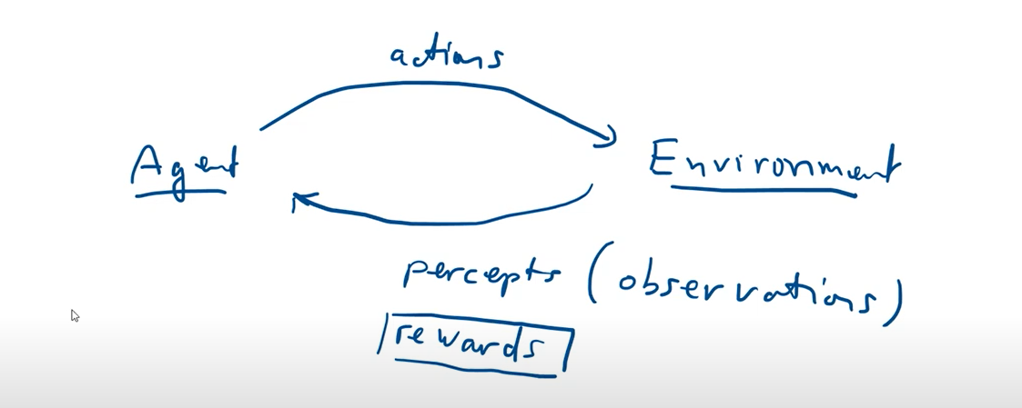

* Action: impact of agent on environment
* Percepts (observations): agent’s perception or description of the environment
* Rewards: want to operate more and more smart thanks to the rewards systems
* EX: A vacuum-cleaner

# **CHAPTER 5: EXPLOIT VS EXPLORE**

## **Exploit and Explore**

* Exploit: To keep exploiting the current state of the environment to find more rewards.
* Explore: To explore different states of the environment instead of keeping the same state too long.
* Depend on the algorithm and the calculation for a particular problem, the exploitation and exploration of the agent may vary.

## **Types of environments**

* **Fully observable:** Agent know completely about its current state
* **Partially observable:** Agent know just a part of its current state
* **Unobservable:** Agent don’t know everything its current state
* **Episodic:** Have statement begins and ends clear.
* **Sequential:** No state begins and ends clear.
* **Other types:** Deterministic vs stochastic, Discrete vs continuous, Static vs dynamic, …

## **Description of the state of Environment**

* + **Atomic:** the simplest, atomic form, doesn't know what's inside.

Example: sunshine state -> clouds -> rain, do not know the cause, components inside.

* + **Factored:** inside the state, in more detail.

Example: rain status, humidity, temperature, amount of clouds, wind speed, or more or less rain

* + **Structured:** both see the details of the properties and see how they are related.
  + Example: database relationships, relationships with multiple attributes in them.

## **A detailed description of Agent**

**PEAS description of agents:** 4 ingredients

* + **Performance Measure**(consider Agent smarter or not)
  + **Environment**(the environment in which the Agent operates)
  + **Actuators**(the part that make agent works)
  + **Sensors**(collect the percepts)

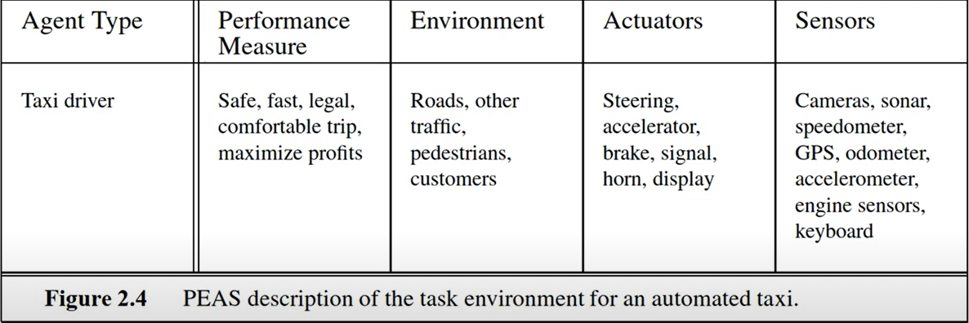

Source:(Russell 2016)

## **Basic kinds of Agents**

### Simple reflex agents

Agents select the action based ONLY on the **current percept**, ignoring the previous percept.

* Can NOT work well in complex cases

### Model-based reflex agents

Agents that try to “guess” the unobserved part of the environment by using some **model of the environment.**

Example: For vehicles without navigation can be based on the velocity and the time to judge the way.

### Goal-based agents

Goal-based agents select action regarding **both state and its goal**

### Utility-based agents

**Goals** just provide a binary distinction between **“DONE” and “NOT DONE”** state.

**Utility** consider **HOW WELL it is done**

Example: Vehicles move to the destination not only care about the destination but also whether it is safe to go, whether the road is short or not, comfortable or not ...

### Learning Agent

A learning agent includes 4 components:

**+ Performance element:** making action based on the perceptions from the environments and giving the correspond actions

**+ Critic:** It will get feedbacks of its actions from the perceptions received from environments.

**+ Learning element:** From the feedbacks, it will set new rules for the actions and improve its performance.

**+ Problem generator (explore):** The ability to explore and try new actions in order to find better performance.

## **Problem description using graph**

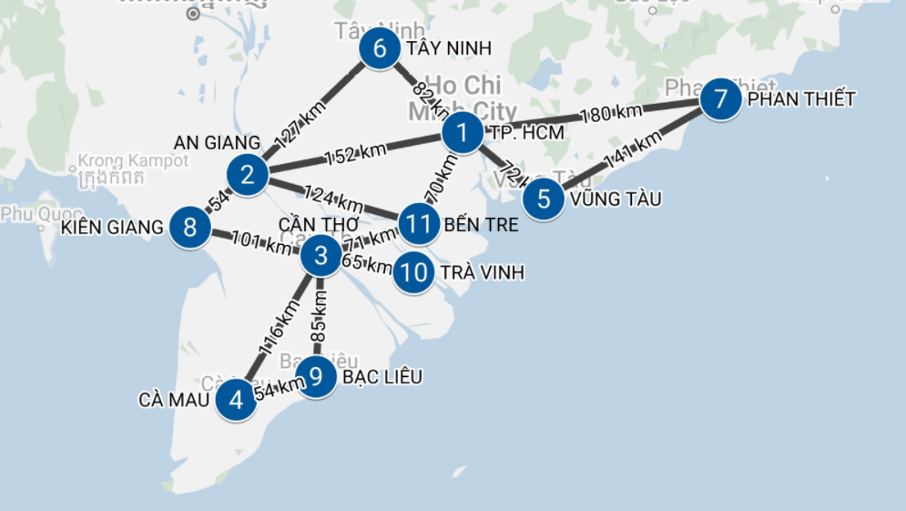

**- Initial state:** The current position, the state in which the agent started.

**- Possible actions:** actions that are applicable to the agent at a certain state.

In the picture:

ACTION(PHAN THIET) = {go(TP. HCM),go(VUNG TAU)}

ACTION(TP. HCM) = {go(TAY NINH), go(PHAN THIET), go(VUNG TAU), go(BEN TRE), go(AN GIANG)}

ACTION(TAY NINH) = {go(AN GIANG),go(TP. HCM)}

ACTION(VUNG TAU) = {go(TP. HCM), go(PHAN THIET)}

ACTION(BEN TRE) = {go(CAN THO),go(AN GIANG),go(TP. HCM)}

ACTION(AN GIANG) = {go(TAY NINH), go(TP. HCM), go(BEN TRE), go(KIEN GIANG)}

ACTION(KIEN GIANG) = {go(AN GIANG), go(CAN THO)}

ACTION(CAN THO) = {go(BEN TRE),go(TRA VINH), go(BAC LIEU), go(CA MAU), go(KIEN GIANG)}

ACTION(TRA VINH) = {go(CAN THO)}

ACTION(BAC LIEU) = {go(CAN THO)}

ACTION(CA MAU) = {go(CAN THO)}

**- Transition model:** result of an action in a state.

RESULT (VUNG TAU, go (PHAN THIET)) = PHAN THIET

RESULT (TAY NINH, go (TP. HCM)) = TP. HCM

RESULT (TAY NINH, go (AN GIANG)) = AN GIANG

RESULT (PHAN THIET, go (TP. HCM)) = TP. HCM

RESULT (PHAN THIET, go (VUNG TAU)) = VUNG TAU

RESULT (KIEN GIANG, go (AN GIANG)) = AN GIANG

RESULT (KIEN GIANG, go (CAN THO)) = CAN THO

RESULT (BAC LIEU, go (CAN THO)) = CAN THO

RESULT (TRA VINH, go (CAN THO)) = CAN THO

RESULT (BEN TRE, go (TP. HCM)) = TP. HCM

RESULT (BEN TRE, go (AN GIANG)) = AN GIANG

RESULT (BEN TRE, go (CAN THO)) = CAN THO

RESULT (AN GIANG, go (BEN TRE)) = BEN TRE

RESULT (AN GIANG, go (KIEN GIANG)) = KIEN GIANG

RESULT (CAN THO, go (KIEN GIANG)) = KIEN GIANG

RESULT (CAN THO, go (CA MAU)) = CA MAU

RESULT (CAN THO, go (BAC LIEU)) = BAC LIEU

RESULT (CAN THO, go (BEN TRE)) = BEN TRE

RESULT (CAN THO, go (TRA VINH)) = TRA VINH

RESULT (CA MAU, go (CAN THO)) = CAN THO

RESULT (VUNG TAU, go (TP. HCM)) = TP. HCM

RESULT (HCMC, go (TAY NINH)) = TAY NINH

RESULT (HCMC, go (PHAN THIET)) = PHAN THIET

RESULT (HCMC, go (VUNG TAU)) = VUNG TAU

RESULT (HCMC, go (TAY NINH)) = TAY NINH

RESULT (HCMC, go (BEN TRE)) = BEN TRE

RESULT (AN GIANG, Go (TAY NINH)) = TAY NINH

RESULT (AN GIANG, go (TP. HCM)) = TP. HCM

**- Goal test:** determines whether a state is a goal state.

**- Cost:**

Step Cost: length traveled by a certain action

Path Cost: the entire length traveled from the beginning to the destination.

# **CHAPTER 6: UNINFORMED SEARCH STRATEGIES**

## **Breadth-first search (BFS)**

### Definition

Breadth-First Search is an algorithm for traversing or searching tree or graph data structures. In which the search consists of only two operations: (a) given a vertex of the graph; (b) add the vertices adjacent to the vertices just given in the list of possible directions to the next. The breadth-first algorithm can be used for two purposes: finding a path from a given origin to a destination vertex, and finding a path from the origin to all other vertices. Leaf nodes generated during algorithm execution will be updated to a queue according to the principle that which node was put in the queue first will be retrieved first during the tree expansion.

### Breadth-ﬁrst search algorithm

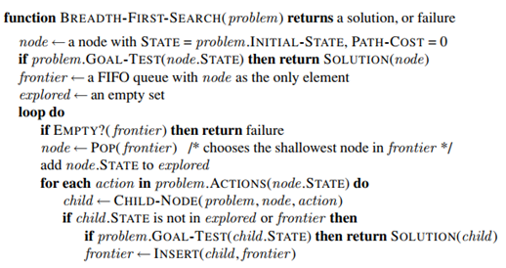

1. Let vertex start in Frontier

2. If Frontier is empty, search fails, finish searching.

3. Take out the top vertex in Frontier and call it O. Put O in Explored.

4. If O is the target, the search is successful and ends the search.

5. Find all sub vertices of O that are not in Frontier and Explored to the Frontier end

6. Go back to step 2

### Measuring algorithm's performance

* **Completeness:** an algorithm will give the solution of the problem if a problem exists and the branch factor b is finite.
* **Optimality:** the breadth-first search algorithm will find the solution with the least intermediate states.
* **Time complexity:** number of iterations when meeting the target state.
* **Spatial complexity:** the maximum number of memory cells used in the algorithm (mainly Queue variables, see the figure below)

## **Uniform-Cost Search**

### Definition

The Uniform-Cost Search algorithm is a variation of the Dijkstra algorithm. It is a searching algorithm used for traversing a weighted tree or graph. The search begins at the root node and continues by traversing the next node with the lowest weight or cost from the root node. Uniform-Cost Search is equivalent to the BFS algorithm if the path cost of all edges is the same. The disadvantage of this algorithm is that it doesn't care about the number of steps involved in the search and is only concerned with the path cost. Hence this algorithm can be stuck in an infinite loop.

### Algorithm

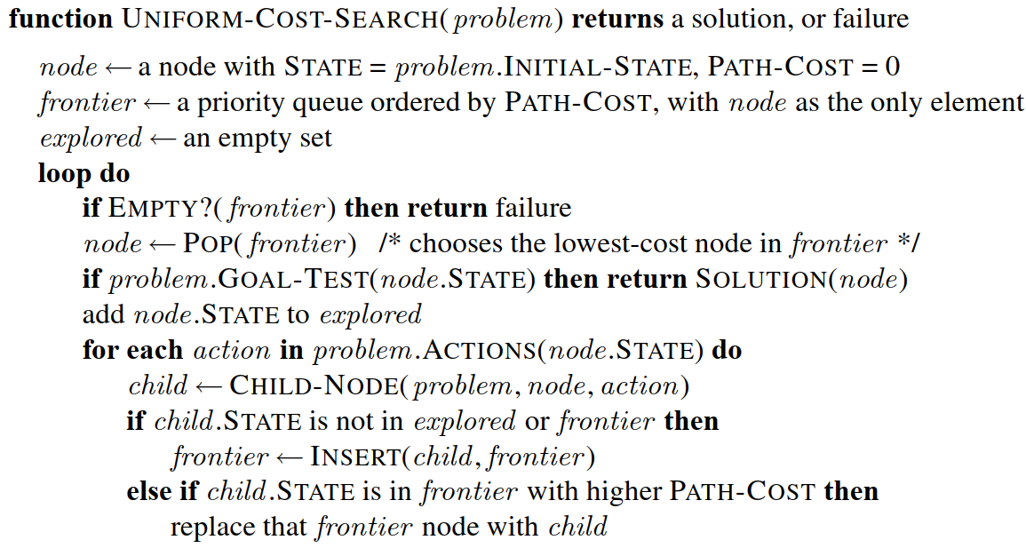

### Measuring algorithm's performance

* **Completeness:** an algorithm will give the solution of the problem if a problem exists and the branch factor b is finite.
* **Time complexity:** O ($b^{1+[C^{*}/ε]}$)
* **Spatial complexity:** O ($b^{1+[C^{*}/ε]}$)
* **Optimization:** Uniform-Cost Search algorithm will find the solution and the lowest cost.

## **Depth-First Search (DFS)**

### Definition

The process of the Depth-First Search algorithm is similar to the Breadth-First Search algorithm.The only difference is that Depth-First Search uses a stack data structure to implement it. For a stack data structure, the last entered states are first retrieved to extend the search tree.

**Advantage:**

* Less memory because it only needs to store a stack of the nodes on the path from root node to the current node.
* Less time to reach the goal node than BFS algorithm (if it traverses in the right path).

**Disadvantage:**

* there is no guarantee of finding the solution.
* The DFS algorithm goes for deep down searching and sometimes it may go to the infinite loop.

### The Depth-First Search algorithm

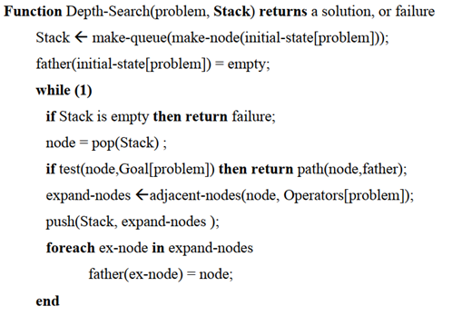

1. Let vertex start on Frontier

2. If Frontier is empty, search fails, end the search

3. Take out the top of the head in Frontier and call it O. Put O in Explored

4. If O is the target, the search is successful and ends the search.

5. Find all the sub vertices of O that are not in Frontier and Explored to the beginning of Open

6. Go back to step 2.

### Measuring algorithm's performance

* **Completeness:** uncertain algorithm for the solution of the internal problem The state space case of the problem is infinite.
* **Time complexity:** O ($b^{m}$)
* **Spatial complexity:** O (b.m)
* **Optimization:** depth search algorithm does not give optimal solution

## **Depth-Limited Search**

### Definition

The depth-first search algorithm above has the advantage that it can generate the solution quickly without costing the computer's memory. However, if the state space of the problem is infinite, it is very likely that it cannot find the solution of the problem when the search direction does not contain the target state. To overcome this disadvantage, we can set a depth limit in the algorithm: if the depth of the state in question exceeds a certain threshold then we do not add nodes adjacent to this state but move on to another search direction.

### The Depth-Limited Search Algorithm

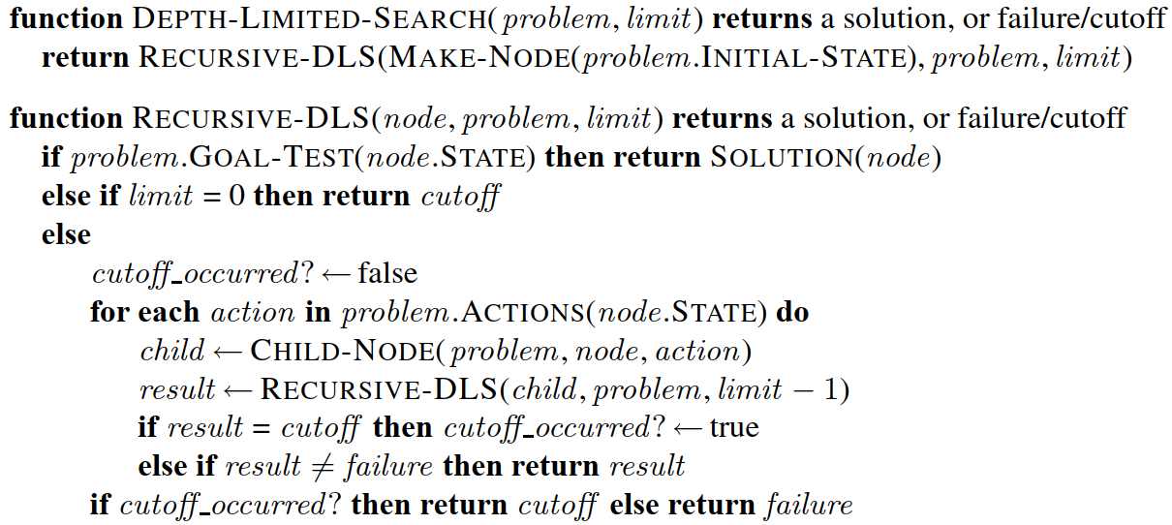

### Measuring algorithm's performance

* **Completeness:** DLS search algorithm is complete if the solution is above the depth-limit.
* **Time Complexity:** O ${ (b}^{l})$
* **Space Complexity:** O (b × ℓ)
* **Optimal:** Depth-limited search can be viewed as a special case of DFS, and it is also not optimal even if ℓ > d.

## **Iterative Deepening Search**

### Definition

The iterative deepening algorithm is a combination of DFS and BFS algorithms. This search algorithm finds out the best depth limit and does it by gradually increasing the limit until a goal is found. This algorithm performs depth-first search up to a certain "depth limit", and it keeps increasing the depth limit after each iteration until the goal node is found.

**Advantage:**

* It combines the benefits of BFS and DFS search algorithms in terms of fast search and memory efficiency.

**Disadvantage:**

* If the maximum depth is not suitable, the limited depth search algorithm will not find the solution of the problem.

### Algorithm

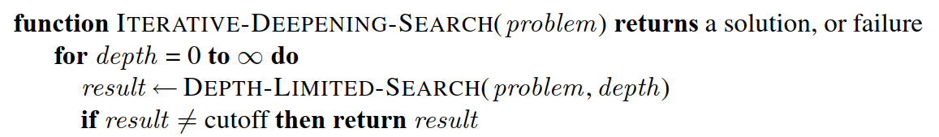

### Measuring algorithm's performance

* **Completeness:** The algorithm returns the solution when the search space is limited.
* **Time Complexity:** O (bd)
* **Space Complexity:** O (b.d)
* **Optimal:** The Iterative Deepening Search algorithm will find the solution if it exists.

## **Comparing uninformed search strategies**

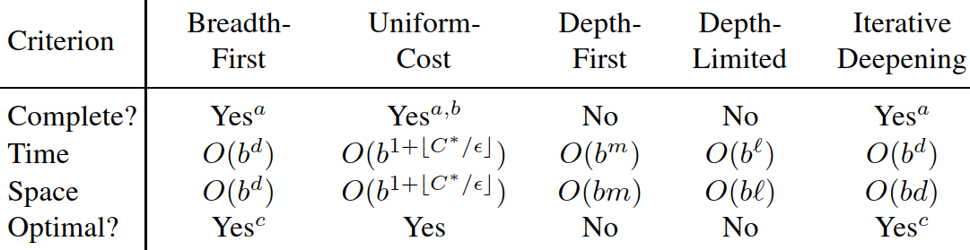

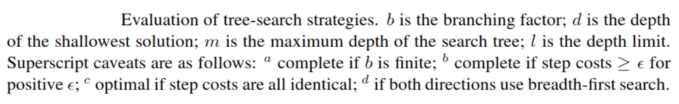

# **CHAPTER 7: UNINFORMED AND INFORMED SEARCH ALGORITHMS**

* Uninformed Search: Search solutions by relying on the problem description and not adding anything more.
* Informed Search: Searching is based on not only descriptive information but also has a way of additional information that helps it know which expand node commands can find the solution more quickly.

## **Best-first search.**

It is a search algorithm which explores a [graph](https://en.wikipedia.org/wiki/Graph_(data_structure)) by expanding the most promising node chosen according to a specified rule.Best First Search. The first (Best First Search) is the breadth First Search guided by the rating function. The thought of this algorithm is that the search starts at the root node and continues by traversing the next nodes whose evaluation function's value is the lowest relative to the rest of the nodes in the queue.

### Valuation function f(n)

* f (n) is the cost estimate for node n (The cost to the destination if we pass through node n).

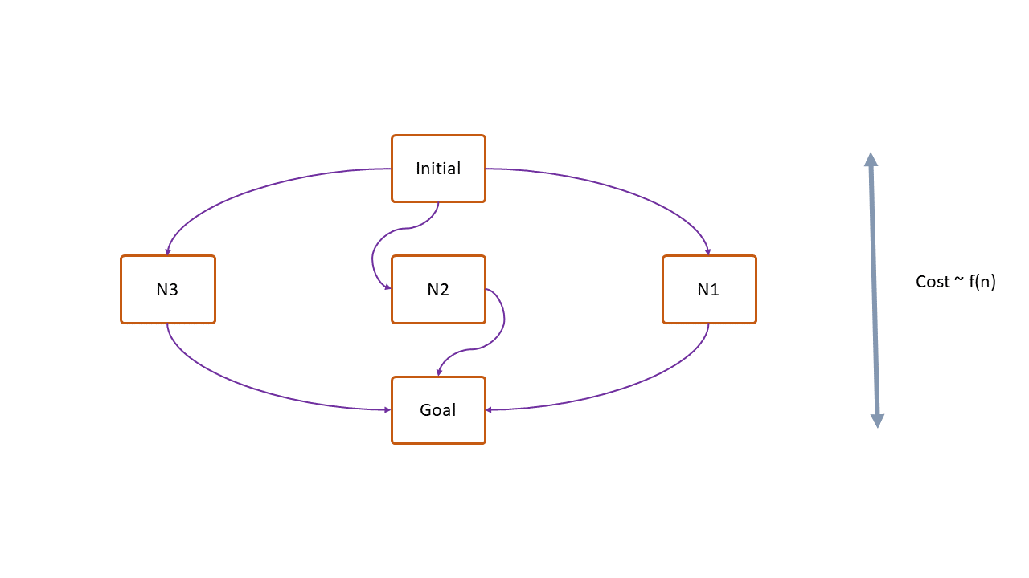

* To build the information to build F(n) we can use additional information temporarily called extra knowledge.
* Example: estimated distance from HCM to An Giang. Assuming the bird's flight route from HCM City to An Giang: 150km. We can use this flight path value as f (n)

### Informed search algorithms.

* **Idea**: A node is chosen based on the estimate f (n). The smaller the node with f (n), the better the path through the node will be to the destination, so select, prioritize, and expand it.
* **Algorithm:**

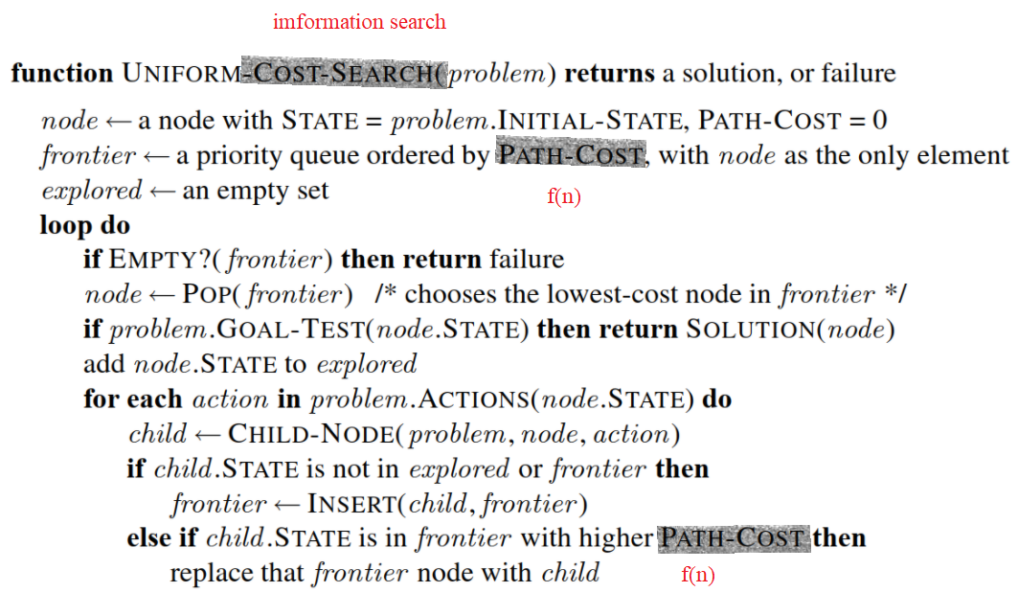

* This algorithm is like most "uniform-cost" search algorithms except changing PATH-COST to f (n).
* Select f (n) = h (n): heuristic function.
* Heuristic function h (n) is the estimated cost from node n to goal.

**For example**:the distance calculated by the flight path from node n to the destination.

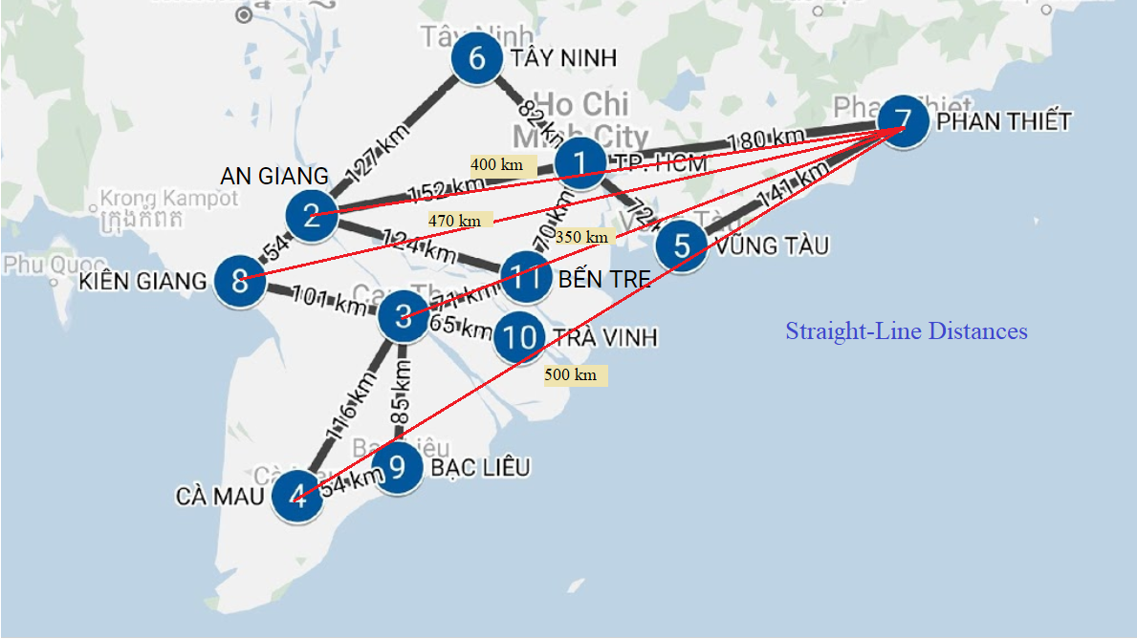

### Best-first search demo.

* **Uninformed** (Depth-first search): Can Tho starting point. From Can Tho we can expand many different nodes such as Kien Giang, Ben Tre, Tra Vinh, Ca Mau, Bac Lieu. Choose Kien Giang to expand to An Giang, Tay Ninh (Ben Tre does not have it because it is already above). Select Tay Ninh and only expand it to Ho Chi Minh and not because it is already above. Select Ho Chi Minh and expand to Vung Tau and Phan Thiet. And Phan Thiet is the Goal of the problem.

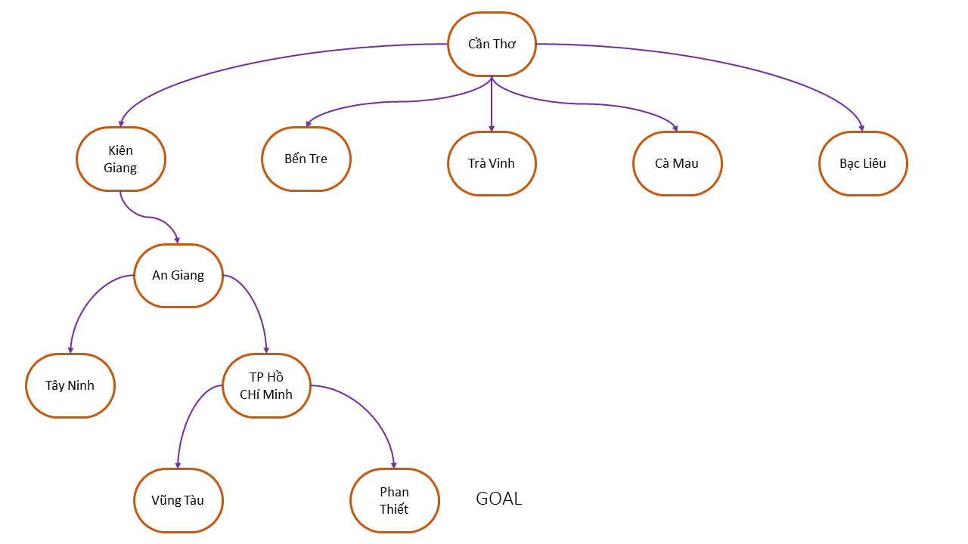

* **Informed** (Best-first search): Can Tho starting point. From Can Tho we can expand many different nodes such as Kien Giang, Ben Tre, Tra Vinh, Ca Mau, Bac Lieu. Based on f (n) we choose Ben Tre and expand to An Giang, Ho Chi Minh. Based on f (n) we choose Ho Chi Minh to expand to Phan Thiet and Vung Tau. And Phan Thiet is the Goal of the problem.

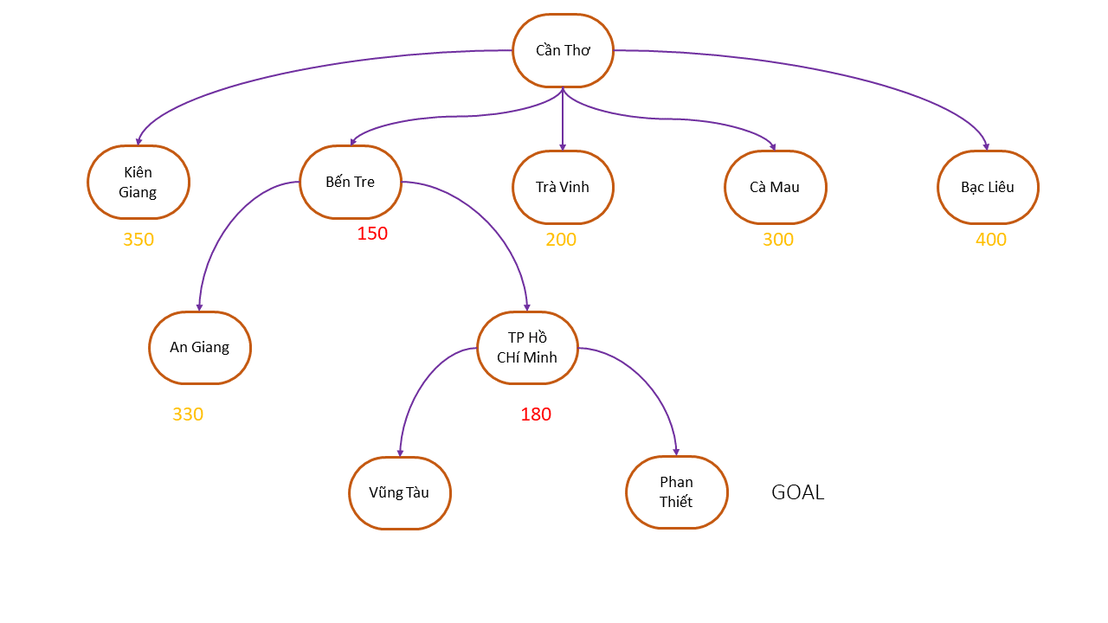

→ Informed finds shorter routes than Uninformed.

### Best-first search is not an optimal algorithm.

**Example**: The problem of finding the way to Ho Chi Minh à Ca Mau.

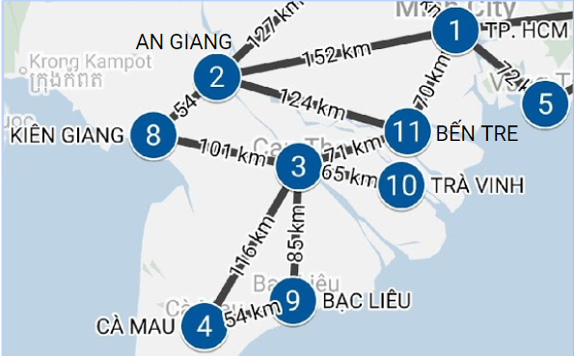

* **Solution:**

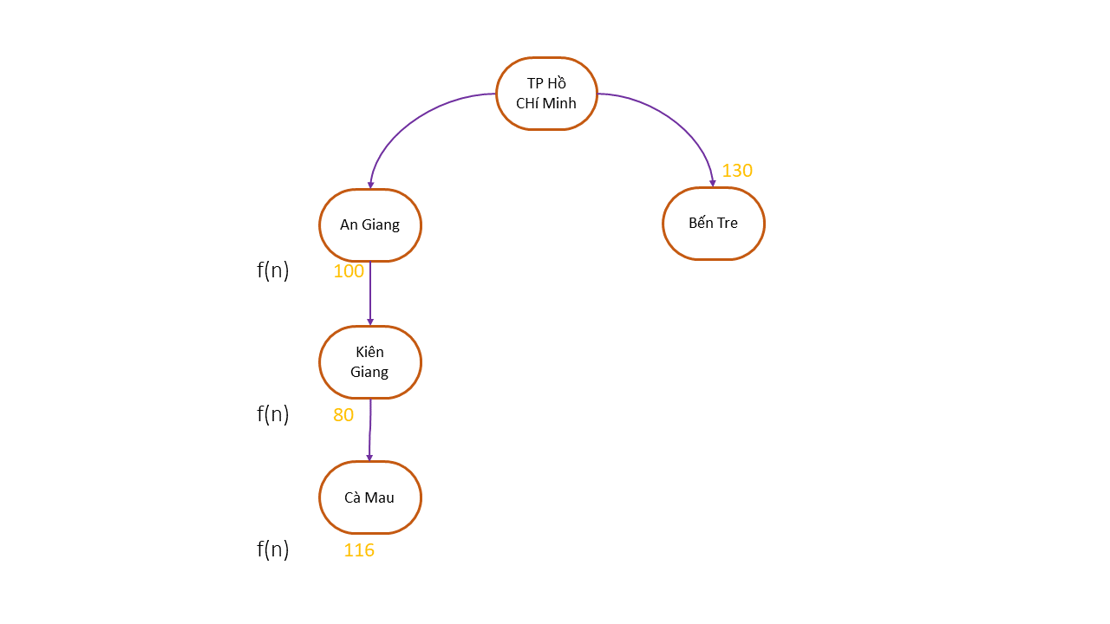

* We started in Ho Chi Minh. In Ho Chi Minh there will be 2 expansions, namely An Giang and Ben Tre. Based on f (n) we choose An Giang and An Giang to expand to Kien Giang. Based on f (n) (80 <130) should choose Kien Giang and Kien Giang and expand to Can Tho. Based on f (n) (116 <130), choose Can Tho and expand to Ca Mau. And Ca Mau is the Goal of the problem.
* But according to the map, we see Best-first search to find the shortest path. The shortest route from Ho Chi Minh to Ca Mau according to the map is: Ho Chi Minh to Ben Tre to Ca Mau.

**Reasons for not optimality.**

* f (n) = h (n): do not have PATH-COST
* Heuristic is bad because its estimation was wrong.

## **A-star search**

f (n) = n.PATH-COST + h (n)

PATH-COST: is the distance from n to the initial node

→ This is a complete and optimal algorithm.

A-star search is an algorithm that always finds the best solution and solution. The condition h (n) is consistent heuristic.

* **Consistent heuristic:**

Heuristic is said to be consistent with the condition that:

h (n) <= cost (n, n ') + h (n')

We have h (n) evaluates the value passing through node n, cost (n, n ') is the actual cost going from node n to node n' where n 'is expanded from n, h (n') is the estimated value from n 'to the destination.

**Example**: Consider node n in Ben Tre.

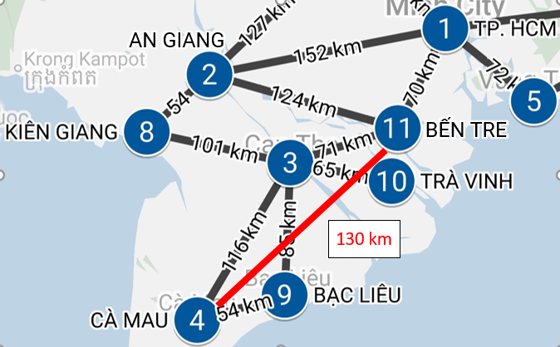

h (Ben Tre) = 130

cost (Ben Tre, Can Tho) = 71

h (Can Tho) = 116

h (Ben Tre) <= cost (Ben Tre, Can Tho) + h (Can Tho) (130 <= 71 + 116 = 187) so h (Ben Tre) is consistent heuristic.

* **Demo finding path A-Star.**

Problem from Ho Chi Minh to Ca Mau:

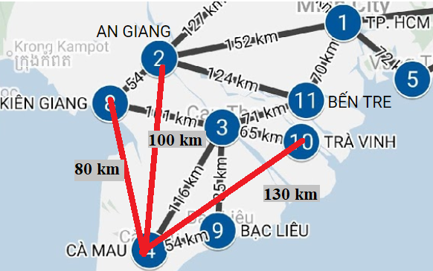

* **Solution:**

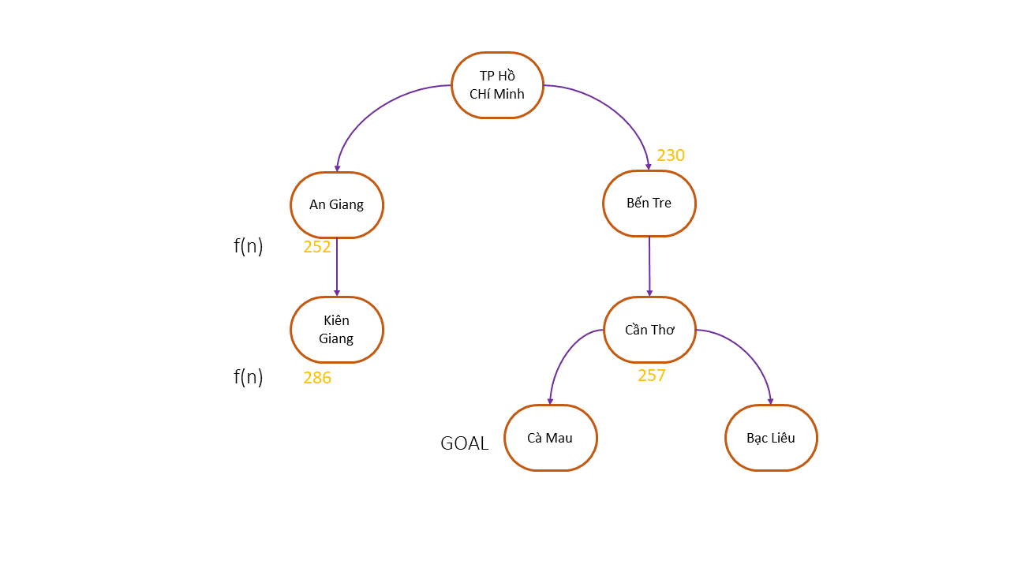

The first position is Ho Chi Minh. From Ho Chi Minh we can expand to An Giang and Ben Tre. Based on f (n) (230 <252), we choose Ben Tre and expand to Can Tho. Based on f (n) (141 + 116> 252), we choose An Giang and expand to Kien Giang. Based on f (n) (206 + 80> 141 + 116), we choose Can Tho and expand to Ca Mau and Bac Lieu. So Ca Mau is the GOAL of the problem.

* **Inconsistent heuristic**

**Example**: Estimated Ben Tre to Ca Mau is 500km. And the estimated gap is higher than the true distance (500> 116 + 71), so the above estimate is inconsistent

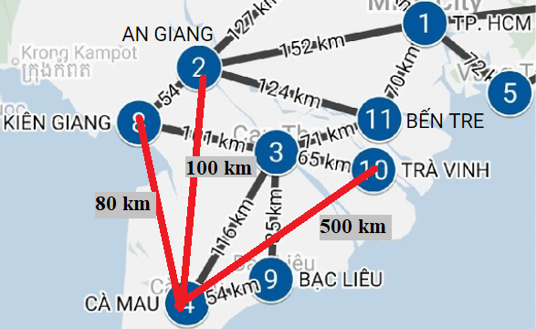

Demo again problem from Ho Chi Minh to Ca Mau:

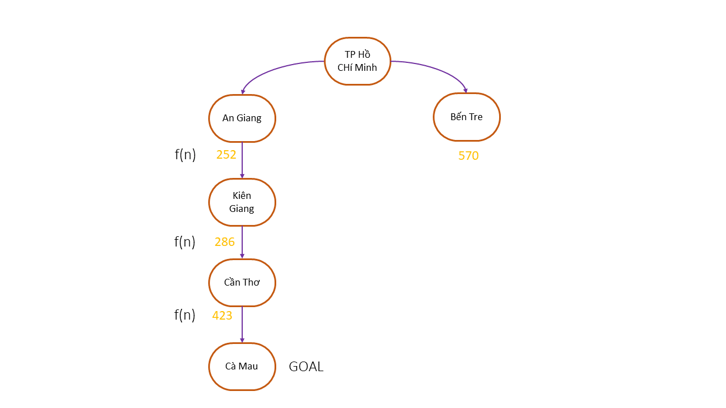

Start Ho Chi Minh and expand to An Giang and Ben Tre. Based on f (n) (252 <570), we choose An Giang and expand to Kien Giang. Based on f (n) (286 <570), we choose Kien Giang and expand it to Can Tho. Based on f (n) (423 <570), we choose Can Tho and expand to Ca Mau. And Ca Mau is the Goal of the problem. But this is not the best route as estimates of Ben Tre to Ca Mau are inconsistent.

* **Zero and accurate heuristic**
* If h (n) = 0 then f (n) = n.PATH-COST then A-star search is Uniform Cost Search (optimal).
* If the consistent heuristic is close to the real value, A-star search can still find the optimal solution and is faster than Uniform Cost Search.
* **SMA-star**

A-star can be seen as an upgraded version of Uniform-cost search, it is a breadth-first search variant. Breadth-first search has one problem is using a lot of memory to resolve memory. And A-star did improve, but still took a lot of memory to deal with. In case of multi-step problems, it is possible to use up the memory without finding the solution. So we have an algorithm to improve this problem is SMA –star (Simplified Memory-bounded A-star). SMA-star is an A-star algorithm, when scanning all the memory, it will remove the node with f (n) too large.

* **Generating heuristic**

It is important that the more accurate it is, the faster it will find the solution, if in the case it is a bad heuristic it may not even be an optimal solution.

* **Use related problem**

This is an issue with little restrictions on actions.

Consider 2 heuristic in 8-puzzle

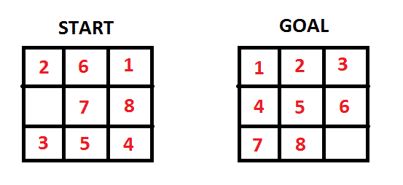

* Consider: h1 is the cell in the wrong position compared to the goal state.
* h1 = 9 <real cost, so h1 is consistent: h2 is the sum of the distance of the cell's

value compared to the location of that cell in goal state.

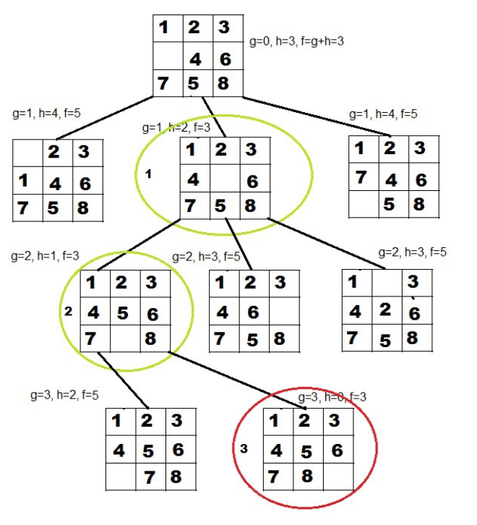

* h2 = 3 + 1 + 2 + ... = 18 <real cost so h2 is consistent
* The bigger the heuristic, the better but the real cost must not exceed the inconsistent heuristic.

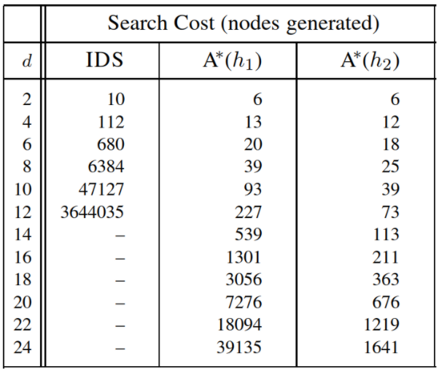

With Search Cost: is the number of nodes created to complete the problem. The lower the number of nodes generated, the better and represents the amount of memory used.

Looking at the table we can see that h2 is better than h1 because it runs much faster

Example: In 8 puzzles are described a cell can move from cell A to cell B if A is adjacent to B vertically or horizontally and cell B is empty.

There are 3 ways Relaxed problems:

1. A cell can move from cell A to cell B if A is adjacent to B. (h2)
2. A cell can move from cell A to cell B if cell B is blank.
3. A cell can be moved from cell A to cell B. (h1).

* **Use Pattern database**

**There are 2 steps:**

Choose a subproblem. Subproblem is the problem of keeping its full regulations but smaller. For example: 8-puzzle is a full problem, 1,2,3,4-puzzle is a subproblem.

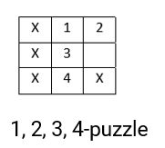

Build a pattern database: contain the solution costs for each subproblem template. With: Solution costs are the number of steps needed to reach the solution.

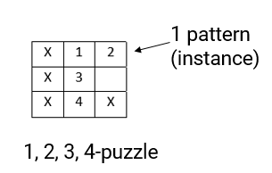

In case of finding many consistent heuristics: the best heuristic is the heuristic with the largest value but smaller than real cost. And I can h(n)=max(h1(n),...hm(n)).

# **CHAPTER 8: LOCAL SEARCH**

The local search algorithm is the solution to solve the algorithms:

Search algorithms in complex environments (without any given conditions):

+ No observable (do not know the current location)

+ No Discrete (the solution is unknown)

+ Non Deterministic (action not determined)

+ Free environment

-How to search:

Find out the state then find the sequence of actions.

## **Hill climbing algorithm.**

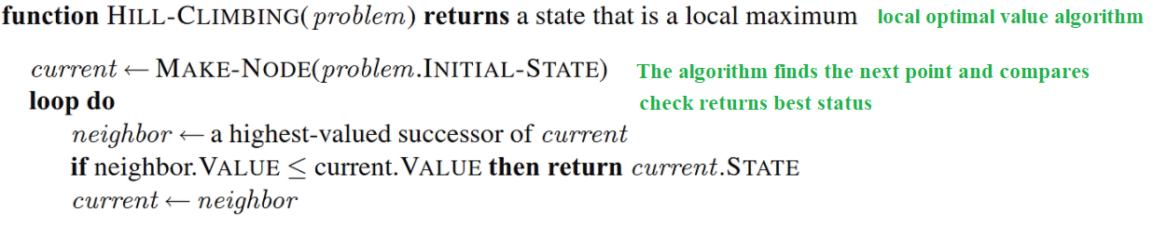

Hill-Climbing is an algorithm belonging to the local search group. It is a very simple but effective algorithm for many problems. In theory, this algorithm may not be able to solve the problem, because it can stop at the local maximum or in flat regions. However, when combined with the strategy of randomly restarting, this algorithm can find a solution.

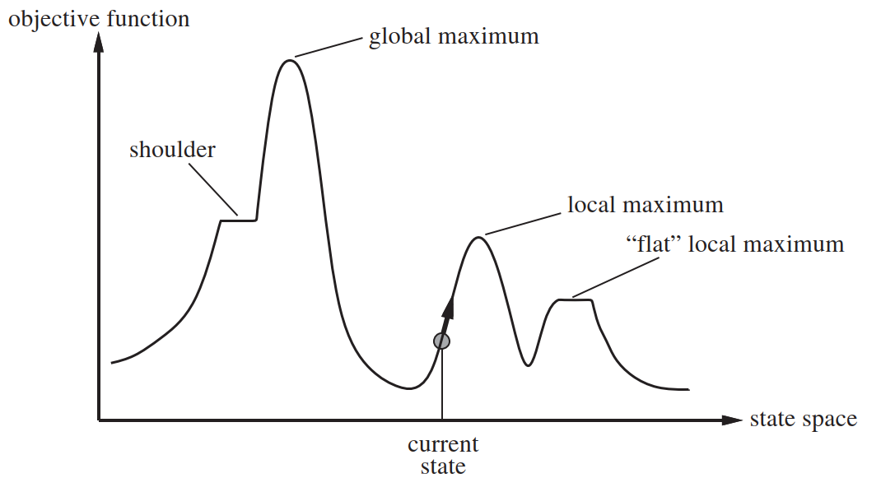

**Processing algorithm:**

* The maximum local points:
* If there are too many neighbor functions, it makes the algorithm speed slow and consumes resources -> (Stochastic hill climbing) randomly generates the state and selects the best state.
* Will be stopped at local points such as local maximum, flat point -> (side way move condition <and add step restriction condition) for horizontal and conditional movement.

**Example**: 8 children (only hill climbing) win: 16%, lose: 84%

After using the side way move: win 94%, lose 6%

* Process global maximum:
* Run random-restart until the condition h = 0 is satisfied
* Can use local beam search to simultaneously run all together independently improving the random-restart algorithm (the disadvantage of consuming too much resources if too many asuccs the solution uses stochastic to choose random by value probability).

## **Simulated annealing algorithm**

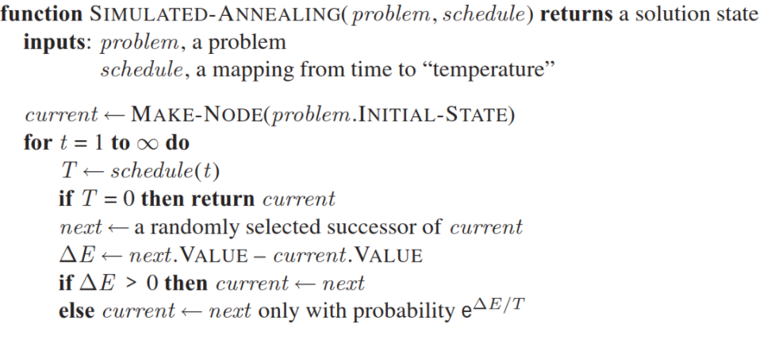

# **CHAPTER 9: SEARCHING IN ENVIRONMENTS**

## **SEARCHING IN NONDETERMINISTIC ENVIRONMENTS**

### The vacuum world

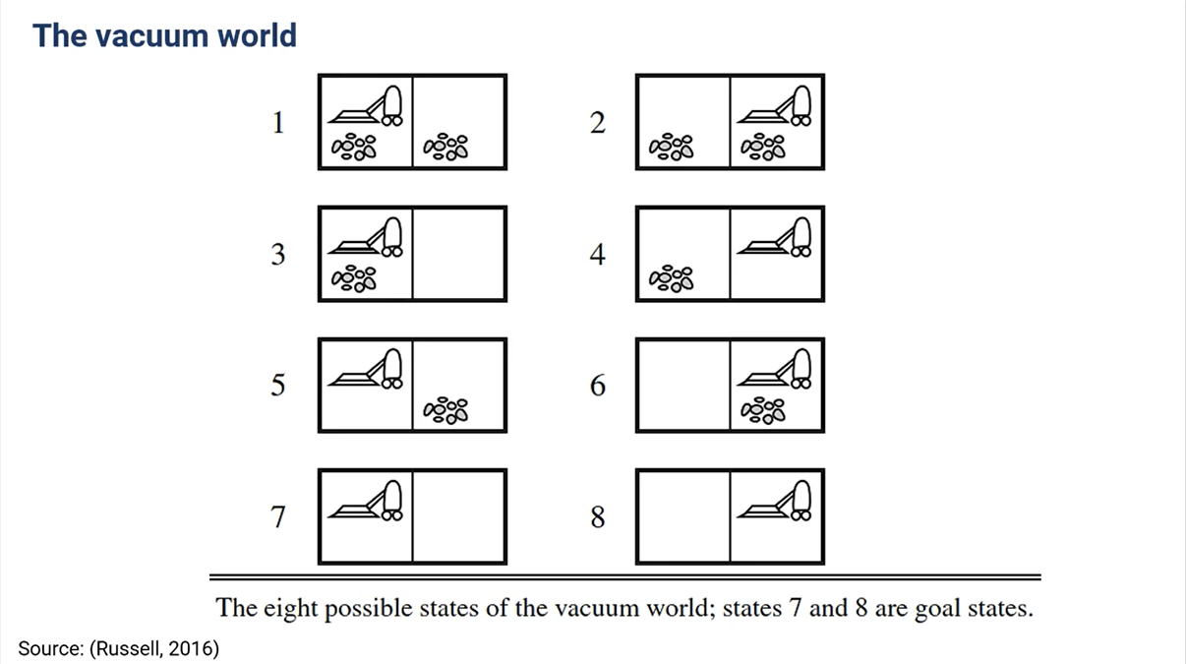

We have 2 changes:

* **Transition model**: RESULTS function

Ex: RESULTS(s, a)= {s1’, s2’, s3’, ..}

* **Solution**:

Ex: [Suck.if State = 5 Then [Right.Suck] else []]

### AND-OR search trees

* 1. **Description**

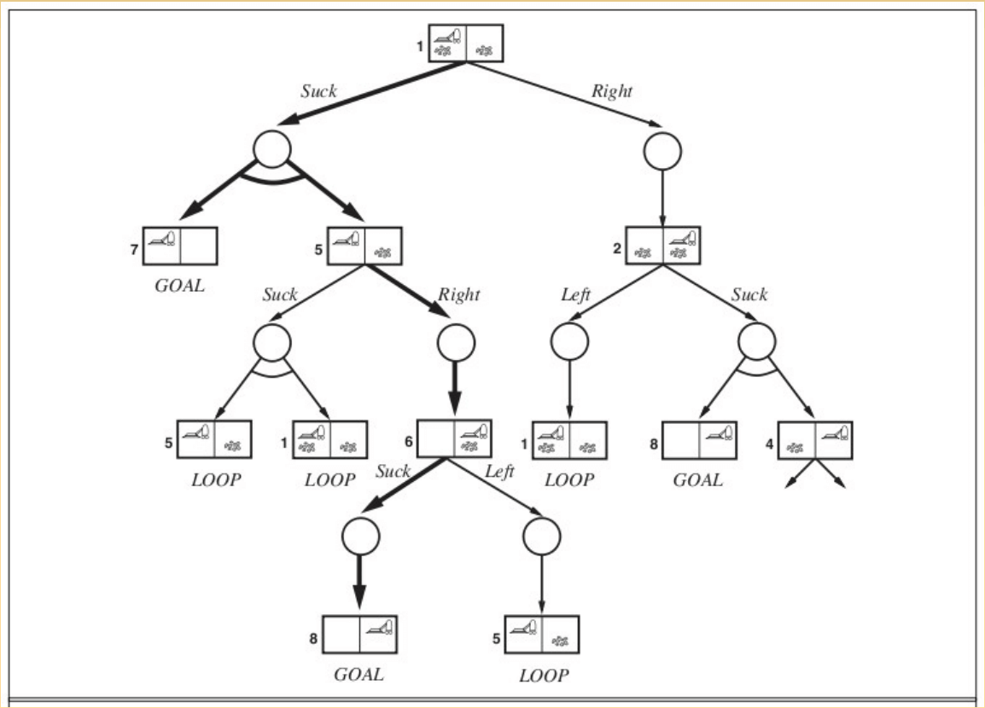

The AND / OR tree consists of OR and AND nodes:

* **OR node:** (state) You can choose to perform one of two actions
* **AND nodes**: (links -> successors) Must handle all actions to come up with different solutions for each problem.
  1. **Solution in AND-OR tree.**

**A subtree that:**

- All leaves nodes : goal states

- OR node: choose 1

- AND node: choose all successors

* 1. **AND-OR graph search algorithm**

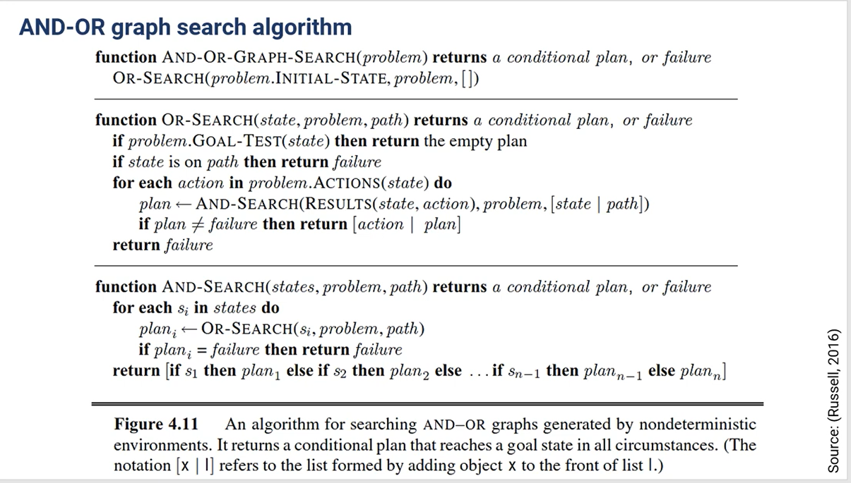

## **SEARCHING IN PARTIALLY OBSERVABLE ENVIRONMENTS**

### 1. Searching with no observation **(Current state is unknown)**

* **Belief state:** A set of actual states (If there are N states then there are 2 ^ N belief state)

b = {…}

Searching in **belief state**

* Components of the **physical problem P:**
* **Initial state** :Ip
* **Possible actions**: ACTIONSp
* **Transition model**: RESULTp
* **Goal test**: GOAL-TESTp
* **Cost**: STEP-COSTp, PATH-COSTp
* Components of the **sensorless problem**:

**Initial state**: all states

**Possible actions**: ACTION(belief state b)

For example, b{s1,s2}, and ACTIONS (b) = ..

**Transition model**: RESULT( belief state b, action a) = new belief state b’

b’ = RESULT(b ,a) = {s1’, s2’}

**Goal test**: GOAL-TEST(b) = True (if all state of b is goal state)

= False otherwise

**Cost**: STEP-COSTP (s, s’) , PATH-COSTP (s)

**Note**: If the physical problem has **N state**, then you have 2N **belief states**

### 2. Searching in partially observable problems

**State prediction**: RESULT(b, a) state action, prediction

**Observation**: O( o: o = PERCEPT (s) and s belong to b) defining the set of acceptances that can be obstructed

**State update**: determines, for each possible perception, the percept will result from the perception

b’= {s: o = PERCEPT(s) and s belong to b

**Example:**

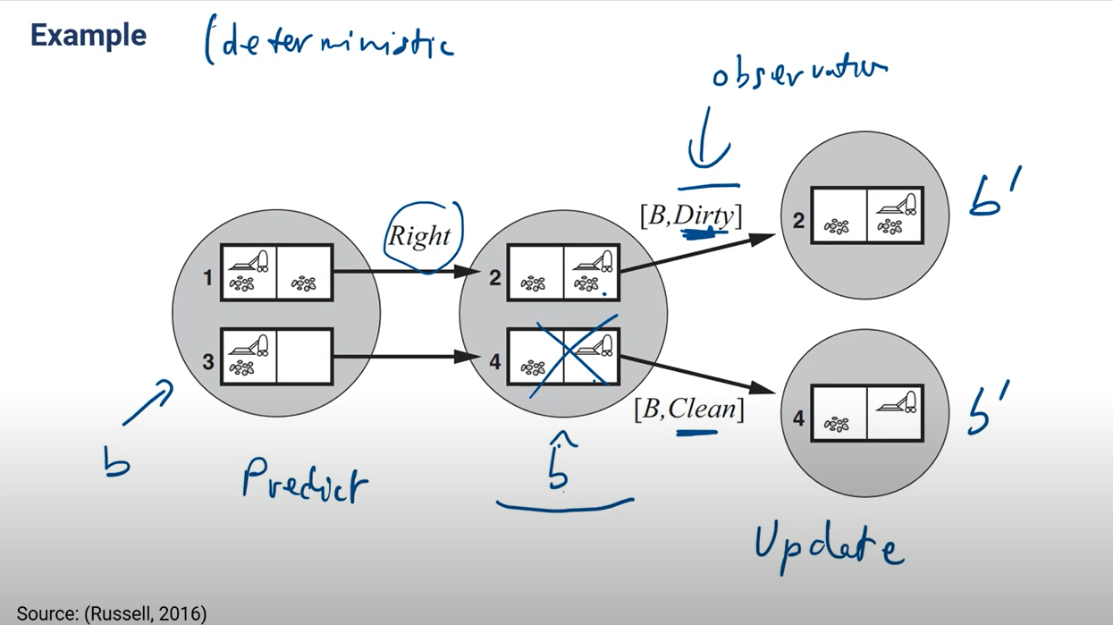

We have observation -> update -> narrow the results

# **CHAPTER 10: ONLINE SEARCH**

## **General**

* Online search algorithms doesn’t have Transition model
* We put agent into the environment
* Find the solution while it running

### Use

Online Search algorithms is useful in

* There is a penalty for (too long computation)
* Non-deterministics environments
* No environment model

### Efficiency:

Competitive Ratio

* **Actual path cost**
* **Shortest path cost** (solution)
* **Competitive Ratio** = Actual path cost/ shortest path cost (often > 1)

Dead-end state

Some actions are **irreversible**, they load to a **dead-end state:**

**For example**: fail in the hole, 1-way street, endless loop

**Safely explorable** state space: don’t have dead-end state

## **Online search algorithms**

### Online depth-first search agent

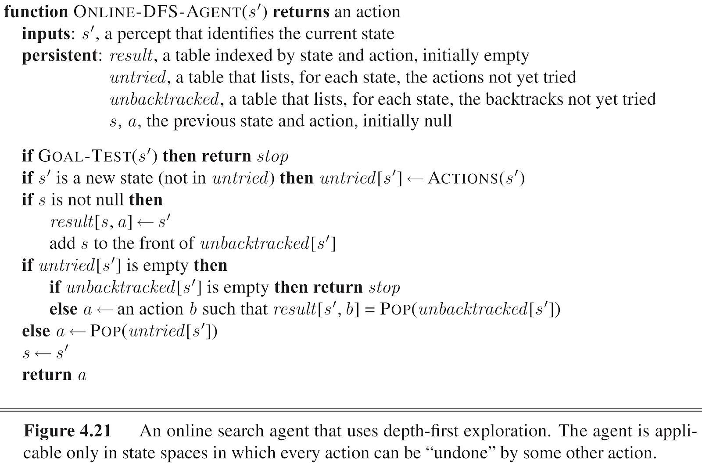

### Learning Real-Time A* agent (LRTA*)

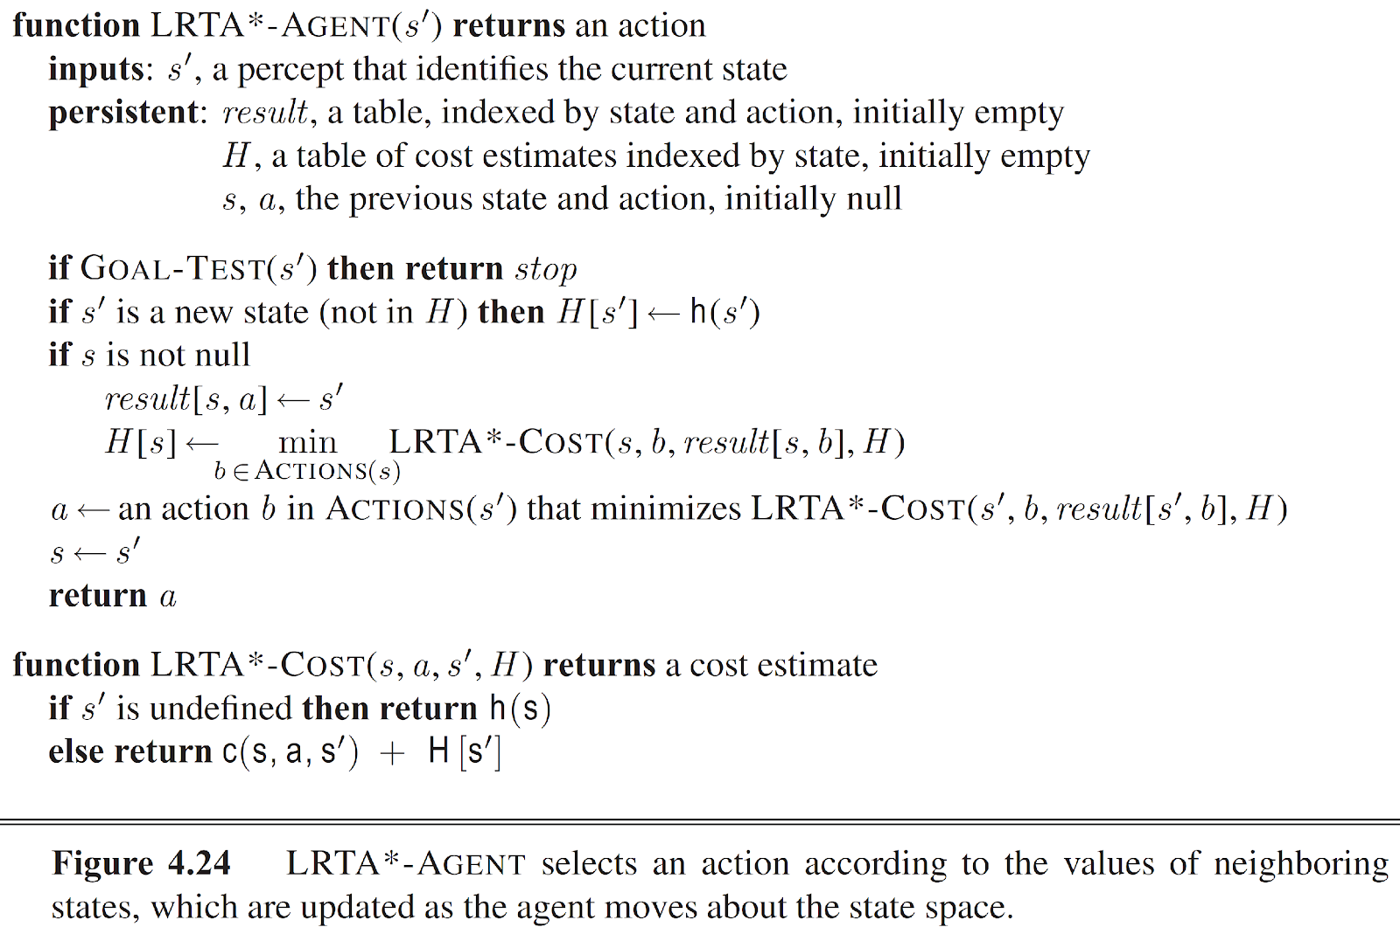

# **CHAPTER 11: CONSTRAINT SATISFACTION PROBLEMS (CSP)**

## **Constraint satisfaction problems (CSP)**

**Previous** algorithms use **atomic state representation** (Black box)

**Now** we move to **factored representation**

* **Defining a CSP**

Three components:

* + X: set of variables {x1, x2, x3, x4}
  + D: set of domains {D1, D2, D3, D4}
  + C: set of constraint {x1 - x4 < 0, x1 + x2 <x3, x3 <10}

A solution of a CSP:

Value for all variables (satisfy constraint)

### Constraint propagation

Using the constraints to reduce the domain (legal values) for a variable, which is turn

Di reduce => Dj reduce => Dk reduce

* **Local consistency**: the key idea of constraint propagation
  + **Enforcing local consistency** in each part of the graph **causes inconsitent value to be** **eliminated** through the graph.
  1. **Node consistency (1 variable)**

Enforcing **domains** to **satisfy** unary **constraints**

For example, ti belong {1, 2, 3, …20}

Di_t = 3

* Ti < 17
  1. **Arc consistency (2 variables)**

Enforcing **domains** to **satisfy** binary **constraints**

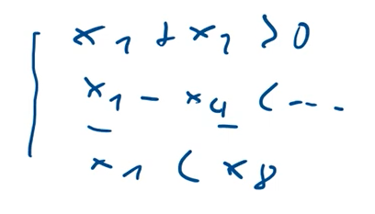

X is arc-consistent with respect to X if

For example, consider the constraint Y = X2

Dx = {0, 1, 2, … 9}

Dy = {0, 1, 2, … 9}

Consider case X=4 => y= 16 (doesn’t satisfy)

* So we enforcing the domain Dx= {0, 1, 2, 3}; Dy = {0, 1, 4, 9}

## **Algorithms**

### AC-3 algorithm

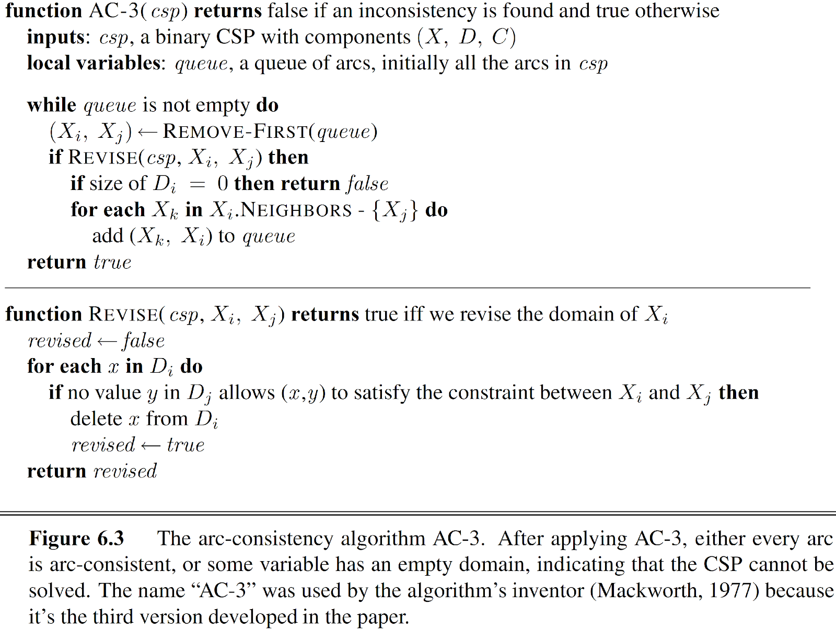

### Backtracking search:

Comments on backtracking search algorithm:

* Select the next variable and its value:

+ For choosing the next variable:

* Random selection: Random selection, however choosing this way sometimes doesn't work.
* Minimum remaining-values ​​heuristic: Select the variable with the minimum domain.
* Degree heuristic: If there are many smallest domains, priority is given to choosing the variable that has the largest number of constrain related to that variable.

+ For choosing value:

* Random selection: Random selection, sometimes choosing this way sometimes doesn't work.
* Least-constraining-value heuristic: choose the value to leave the most choices for other variables.
* Inference (Propagation constraint) to reduce the domain of other variables when there is a new assignment {var = value}

+ Forward checking: check the domain of the variables with constraints to it. However, forward does not detect all conflicts

+ Maintaining arc consistency: checks the domain of all variables.

# **Chapter 12: Solve CSP by using algorithms**

## **Local Search**

### Definition

* A set of variables, domains for these variables, and constraints on their joint values. A node in the search space will be a complete assignment to all of the variables.
* Change the value of that variable so that the constraint quantity is violated.

Input:

* A set of variables
* A function such that domain (X) is the domain of variable X
* Set of constraint to be satisfied the constraints

Output: Complete assignment that satisfies the constraints

**For example:** 8-queens

Assign a value to a variable that minimizes confliction with other variables. (Min-conflict)

### Min - Conflict

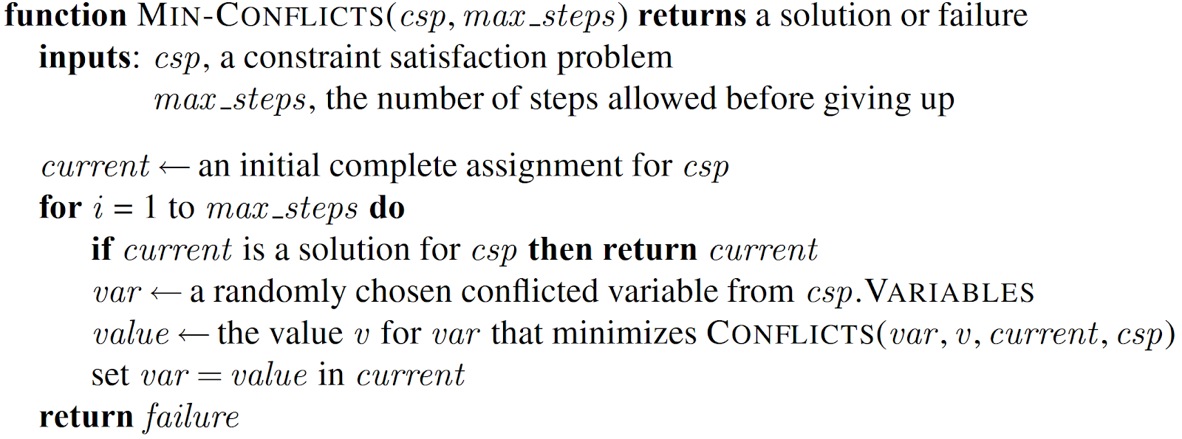

1. Assignment for all variables (complete assignment)
2. Loops from i to max_steps
3. Check all constraints so that it is satisfied, then return current (solution)
4. Take a random variable that collides with other variables and assign a value to it such that it minimizes conflict.

**For example:**

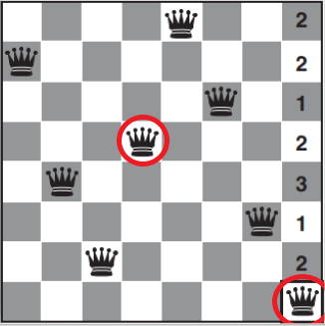

Randomly available

1. Check the solution (This is not solution because of a pair of attacking queens each other).
2. Choose a randomly queen and perform conflicts in the specified domain to calculate the number of constraint violations in domain (0 – 7)

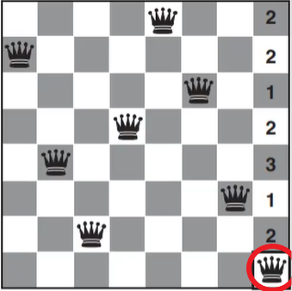 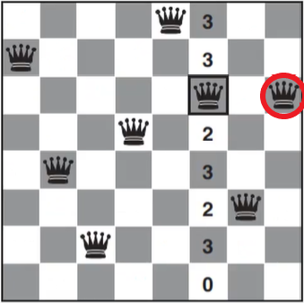

1. Moving the post to the smallest conflict then selecting the variable that still violates constraint, then check solution if not, it will continue to conduct similar step 2.
2. Finally, check solution

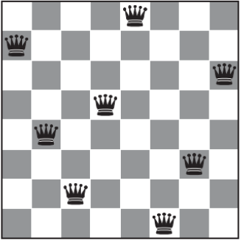

## **Constraint Graphs**

Tree-structured CSP

Main step:

* + 1. Pick a variable to be the root. Sort variables such that each variable appears after its parent
    2. Enforce arc consistency on sorted variables
    3. Choose values for variables from consistent domains.

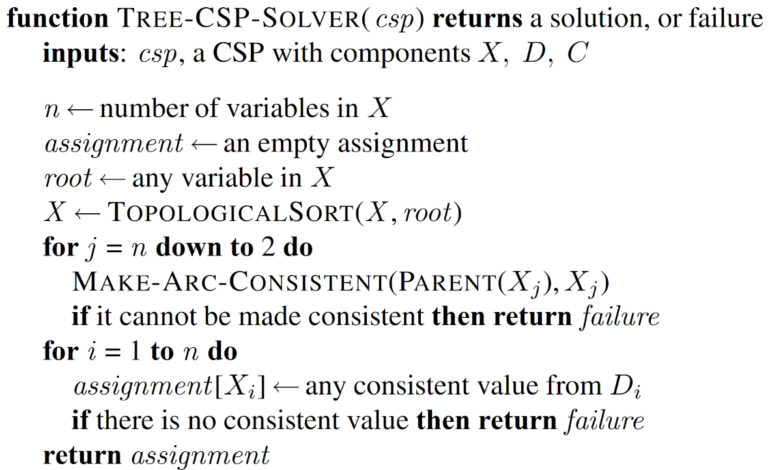

1. Create an empty assignment (None of variable have been assigned yet)
2. Select to a randomly variable in X array then arrange TopologicalSort
3. Reduce domain to make sure that constraint is the consistent, if not returning failure.
4. Assign [Xi] - any consistent value from [Di] if there is no consistent value then return failure.

# **PART 3: FINAL PROJECT**

# **Introduction to project**

* Our final project is called AI snake game where the snake in the game can automatically find the way to go to the food which will be placed randomly on the map after be eaten by the snake and avoid hitting the barrier which is created by player.
* This is the interface of the game:

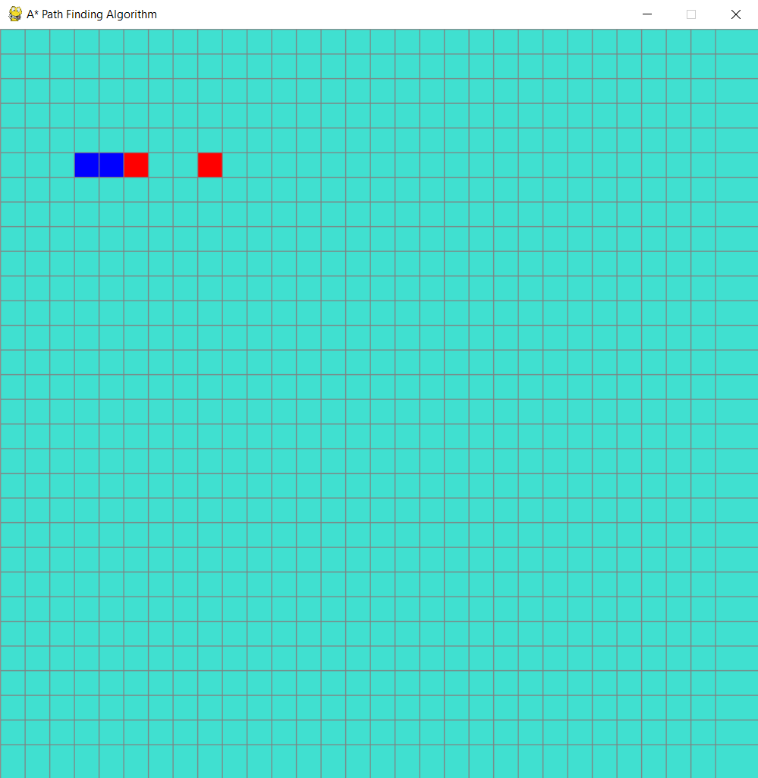

* To play the game, first of all, we need to draw the barrier by using your mouse and clicking on the map where you want to draw the barrier

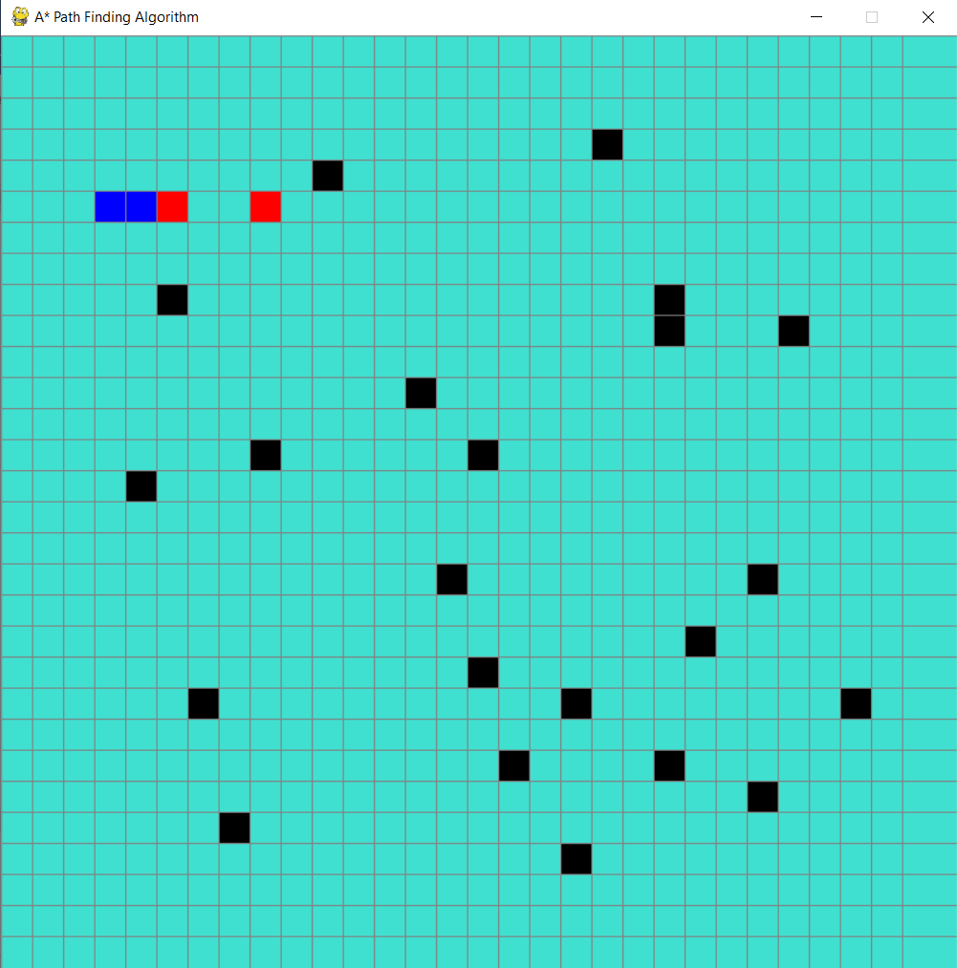

* After that, we press the space button on the keyboard to start the game

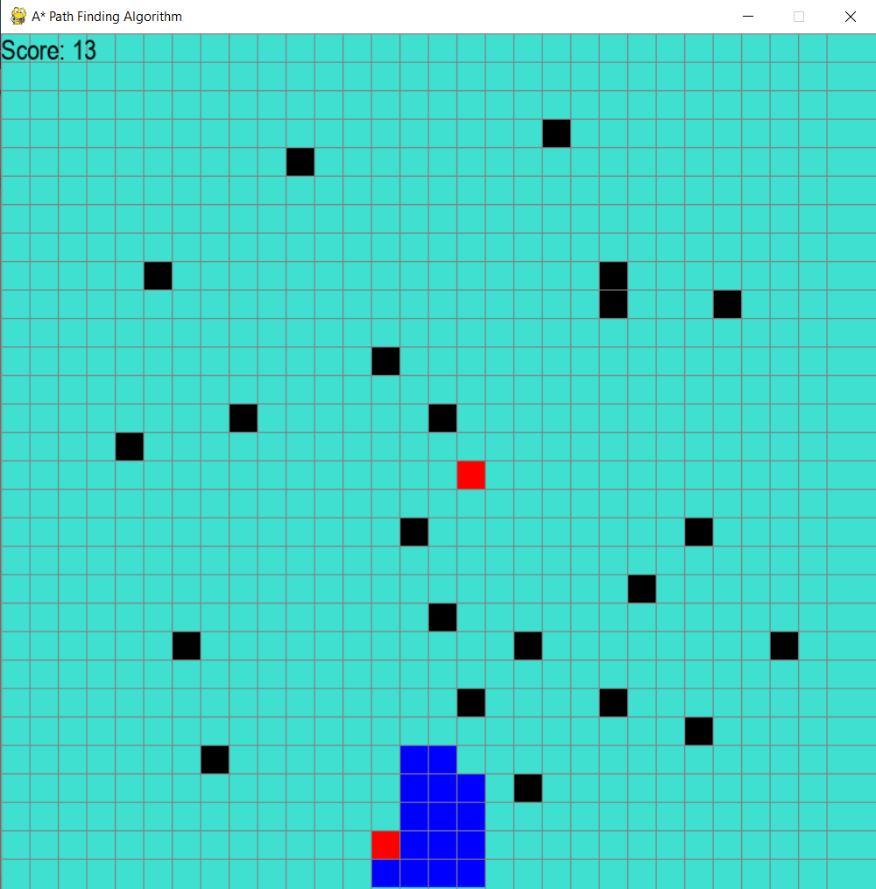

* When the game started, the snake will automatically find the way to eat the food, after eat a food, the other food will be placed randomly and the snake will continue find the way to eat that food
* After eat a food, the score will be added 1

# **Source code**

* We use library Pygame which is popular in programming video games by python to render our game.

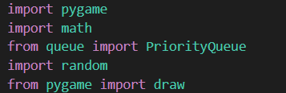

* We also import draw from pygame library to draw the grid of the game
* We set the caption of the game by using this:



* Firstly, we create class Spot to create properties contained in a square
* In class Spot, we have function def update_neighbors(self, grid) to update the neighbors after the snake move a step

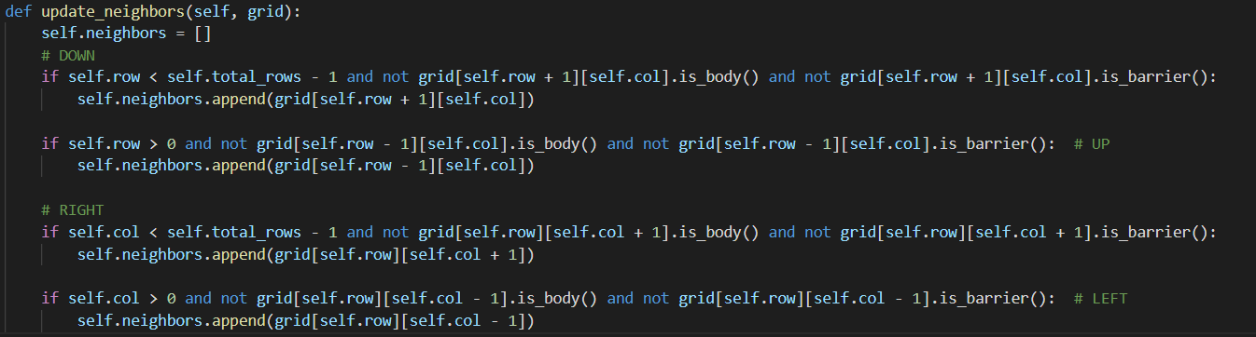

* We have function make_grid which add all note into a grid array after that function draw_grid to draw the vertical line and the horizontal line of the map. Finally, function draw will render all of note in grid array and the vertical line and the horizontal line.

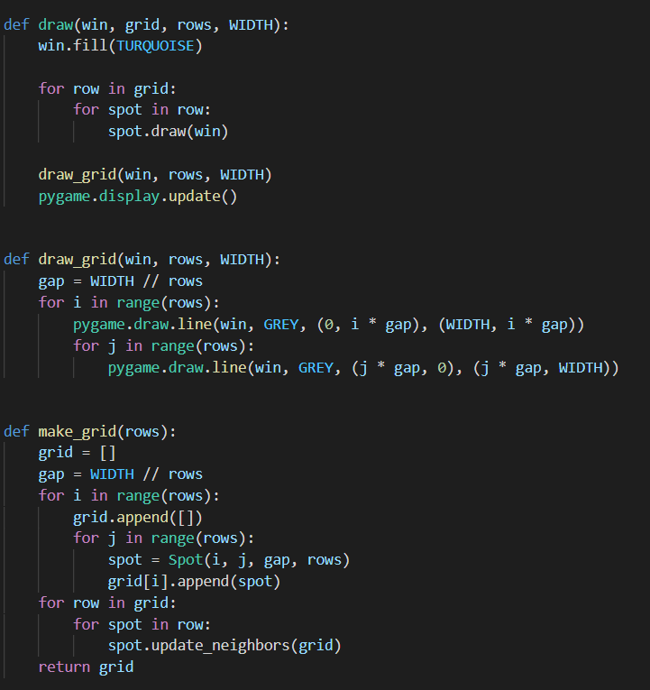

* The snake in our game finds the way to eat the food by using A* algorithm

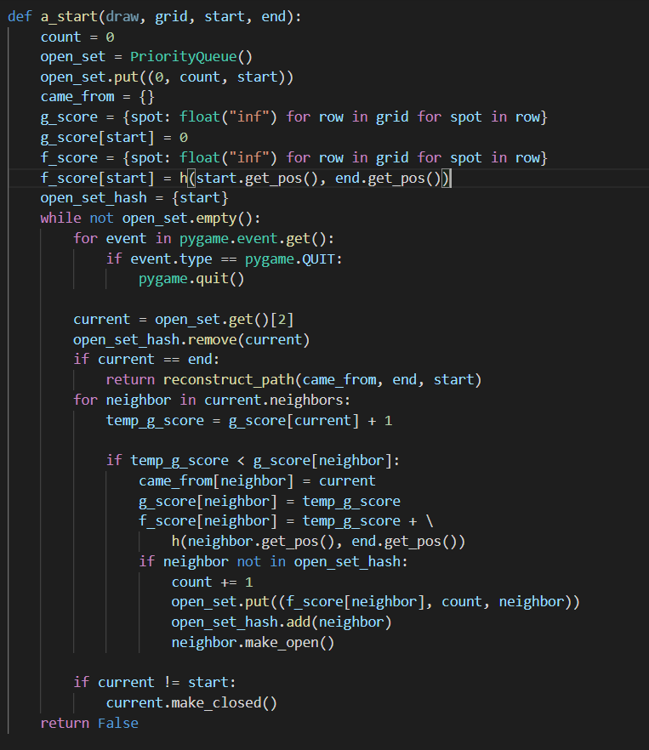

* After the agent finds the result by using A* algorithm, the function reconstruct_path to return the path from the snake to the food.
* Because some unknown reason the direction from class SnakeGame return None so that, we make another A* algorithm by using other heuristic function

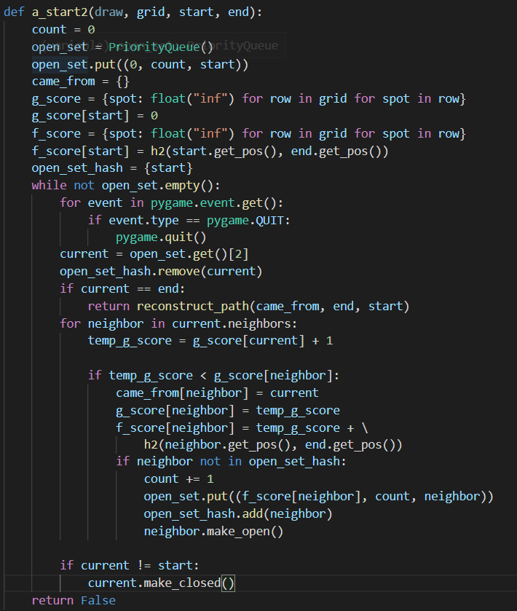

* Here is 2 heuristic functions:

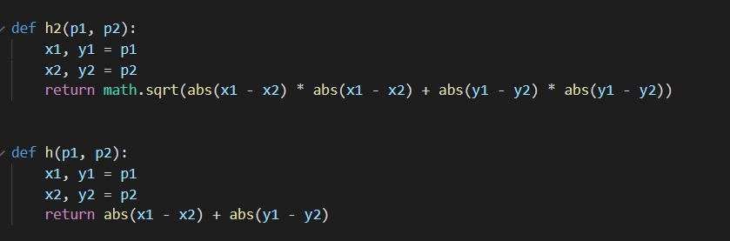

* Secondly, we create class SnakeGame which create main game
* In class SnakeGame, we have main function which build the main game

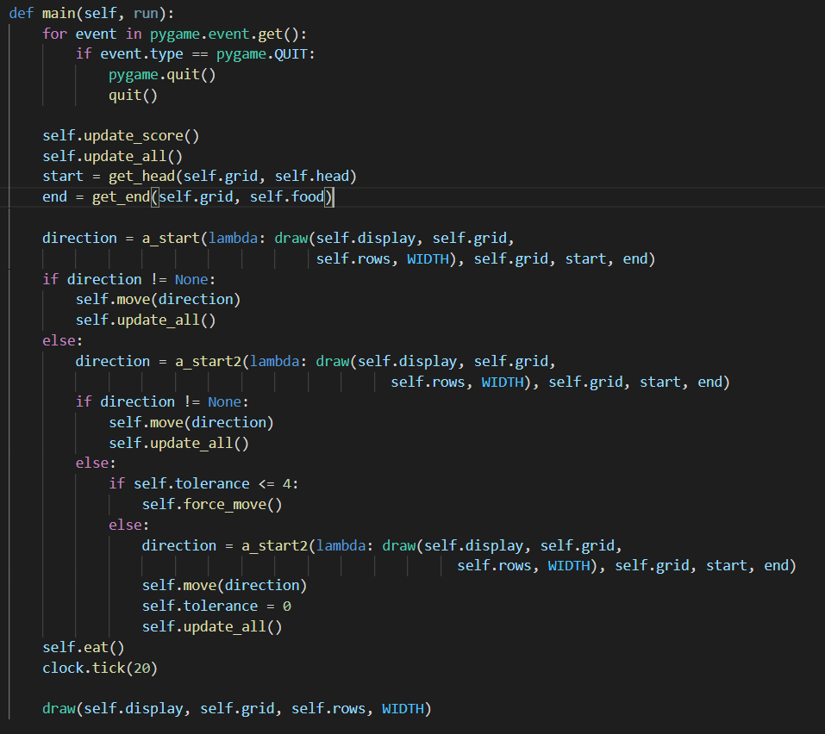

* In main function, first we update whole game with the grid, score, snake…, after that, we use the first A* algorithm if the direction return None, we will use the other A* algorithm, if the second A* algorithm return None again, we use force_move function to let the agent move randomly maximum 4 steps and then use the second algorithm again.
* Finally, when the snake eat the food, the food will be randomly placed and the grid will update.
* We also have the get_clicked_pos function to draw the barrier by clicking

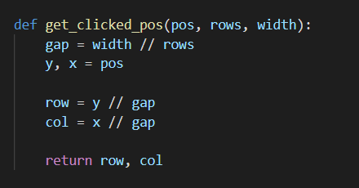

* Finally, the main function to build the whole game

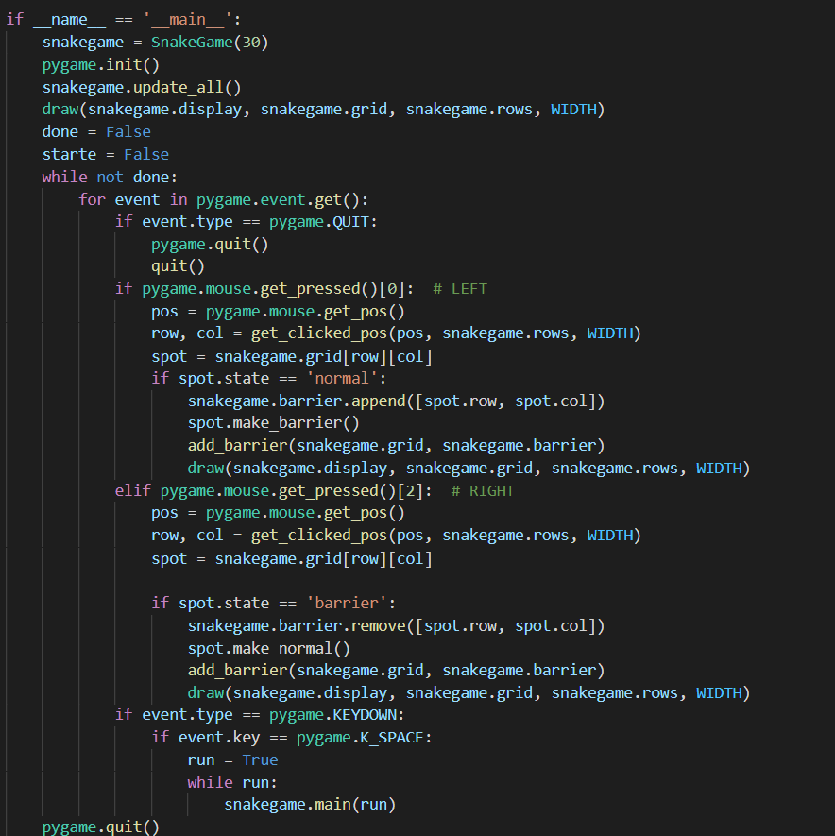

# **References**

Idea of snake game. (2021, October, 27). Retrieved from

<https://www.youtube.com/watch?v=--nsd2ZeYvs>

1. A* algorithm. (2021, November, 10). Retrieved from

<https://www.youtube.com/watch?v=JtiK0DOeI4A>